

Niagara College
Manager Training Manual –Travel and Expense

Table of Contents

Approving an Expense Report – Traditional PeopleSoft Form 3
Approving an Expense Report – Fluid Page 5
Assigning a Delegate 7

The Travel and Expense module can be accessed through the MyNC portal by clicking on the Oracle - Financials icon.



Approving an Expense Report – Traditional PeopleSoft Form
Click on the navigator icon, then follow the path:

Navigator -> Travel and Expenses -> Expense Reports -> Approve Transactions

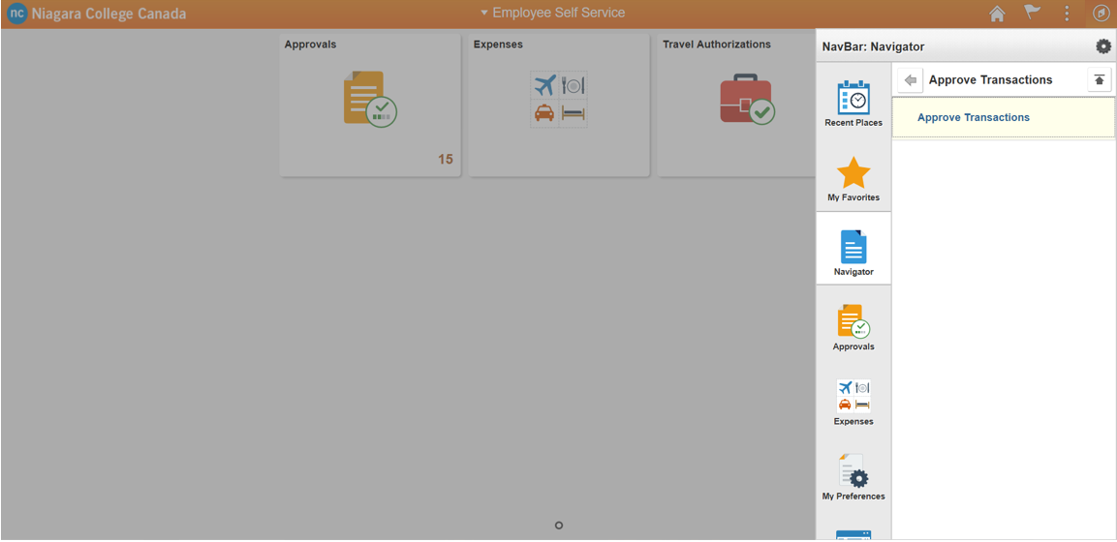

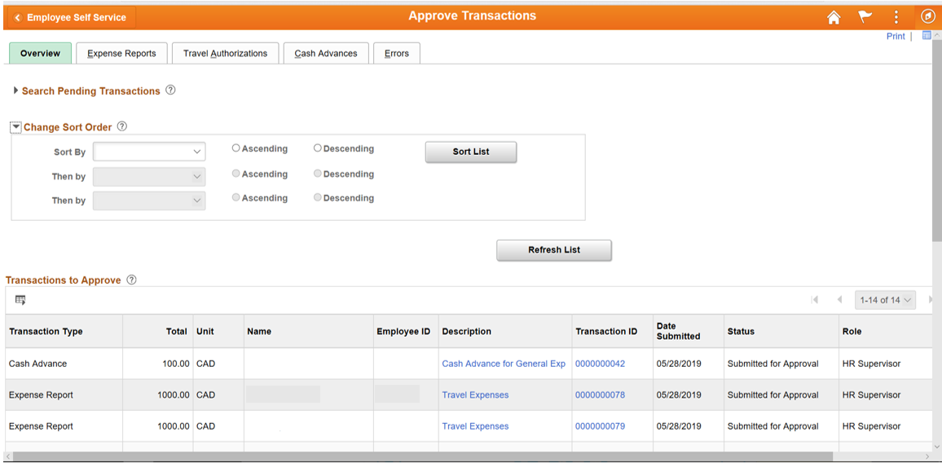

On the Overview tab you will see all the transactions requiring your approval. You can also navigate to any of the other tabs to narrow your view down to those specific request types. Click on a request to see the Approval screen.

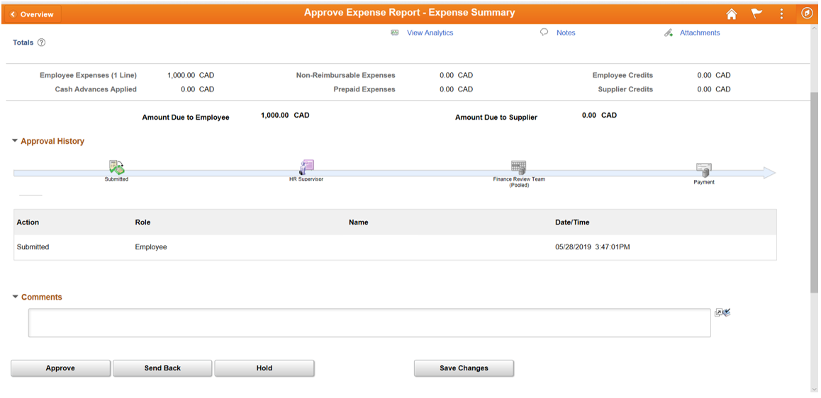

On the Approval screen you can
- View the current status in the overall approval process
- Provide comments or requests for more information
- Approve the request
- Send it back to the employee for more information
- Reject it

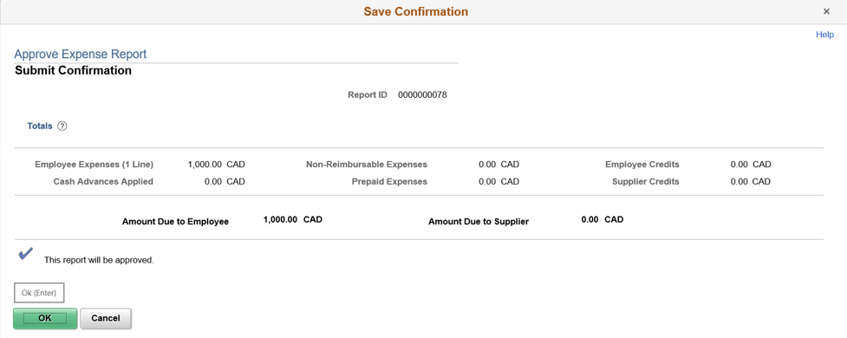

When approving the request, a new window will pop up asking you to confirm the approval. Click Ok to continue.

Approving an Expense Report – Fluid Page

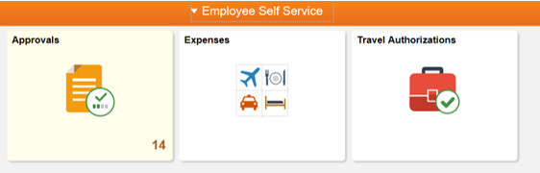

From the home screen click on the Approvals tile.

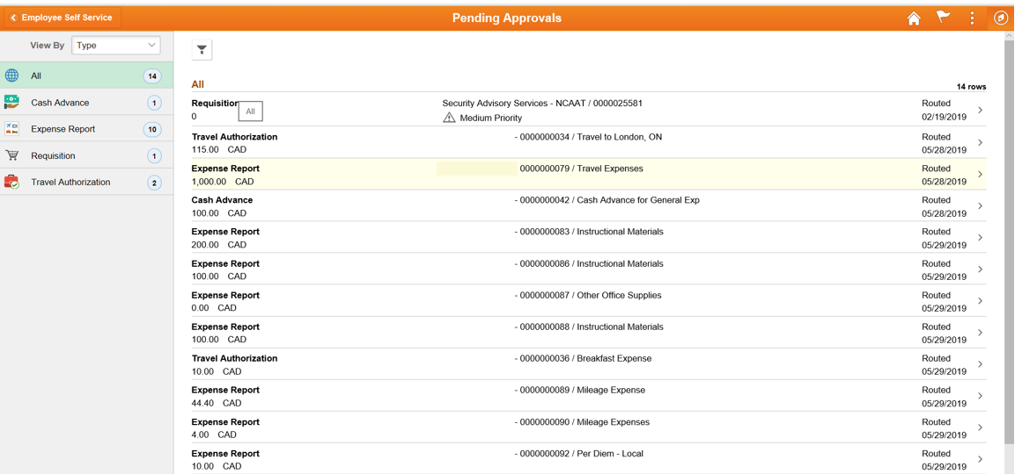

On the left-hand side of the screen you can select All to see all the transactions requiring your approval or you can select any of the other options to narrow your view down to those specific request types. Click on a request to see the Approval screen.

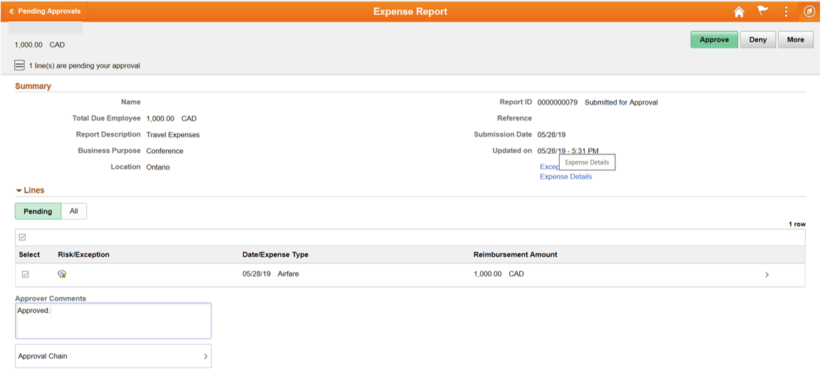

On the Approval screen you can
- Provide comments or requests for more information
- Approve the whole request or individual expense lines
- Send it back to the employee for more information (More-> Send Back)
- Deny it

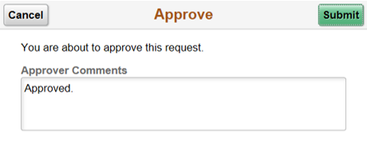

When approving the request, a new window will pop up asking you to confirm the approval. Click Submit to continue.

Assigning a Delegate

To assign a delegate to approve on your behalf while you are away from the College, click on the navigator icon and scroll down to My System Profile

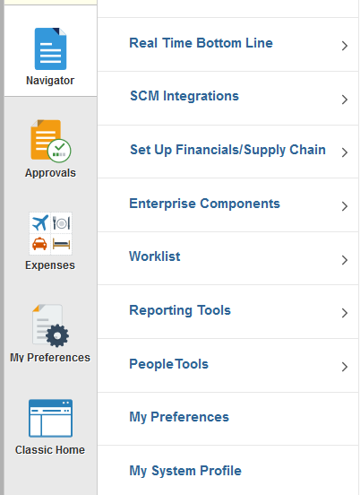

Scroll down to Alternate User and enter the username of the person who will be your delegate and the From and To dates for when you will be unavailable.

