

Niagara College
User Training Manual –Travel and Expense

Table of Contents

Expense Report – Traditional PeopleSoft Form 3
Adding Out of Pocket Expense Lines 4
Adding Corporate Card Transactions 6
Associating a Travel Authorization 7
Applying a Cash Advance 8
Submitting Your Expense Report 8
Travel Authorization – Traditional PeopleSoft Form 9
Cash Advances – Traditional PeopleSoft Form 11
My Wallet – Traditional PeopleSoft Form 12
Viewing the Status of an Expense Report – Traditional PeopleSoft Form 14
Expense Report – Fluid Page 15
Adding Out of Pocket Expense Lines 17
Adding Corporate Card Transactions 19
Associating a Travel Authorization 20
Applying a Cash Advance 21
Submitting Your Expense Report 22
Travel Authorization – Fluid Page 22
My Wallet – Fluid Page 23
Viewing the Status of an Expense Report – Fluid Page 24
Adding Travel and Expense Link to Mobile Home Screen 26
iOS 26
Android 27

The Travel and Expense module can be accessed through the MyNC portal by clicking on the Oracle - Financials icon.

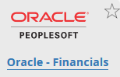

Expense Report – Traditional PeopleSoft Form

Navigator -> Employee Self Service -> Travel and Expenses -> Expense Reports -> Create/Modify

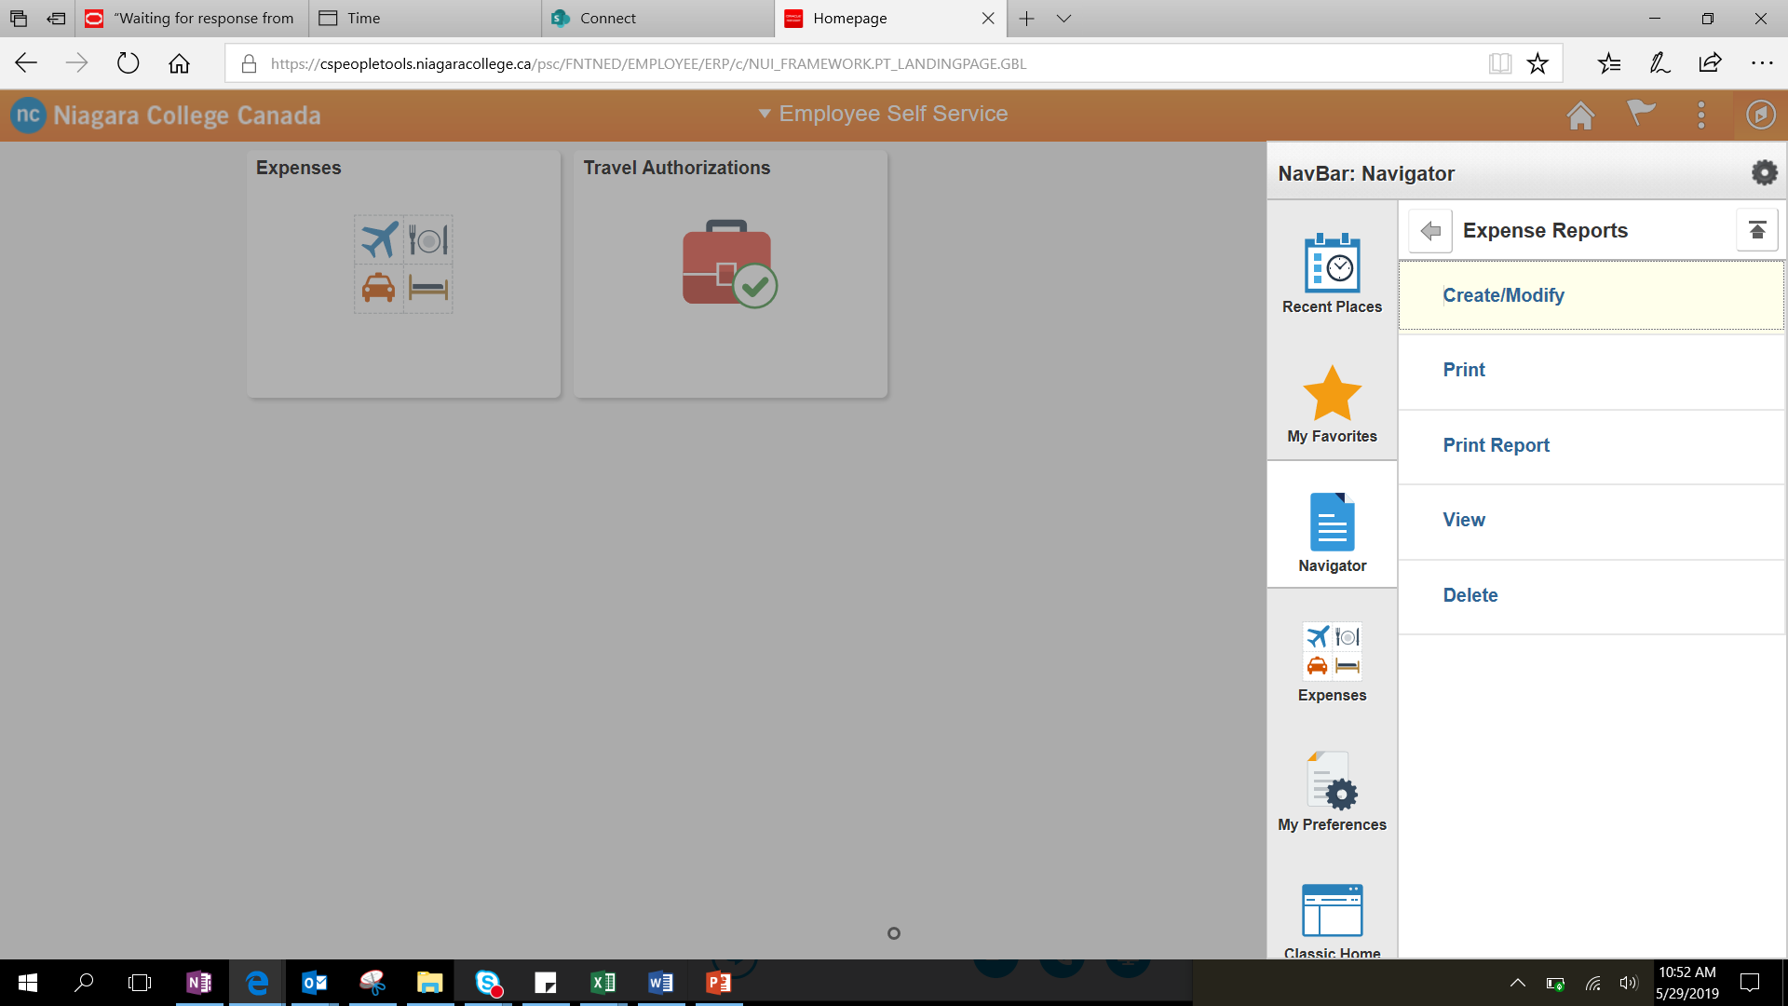

Click on the navigator icon, then follow the path:

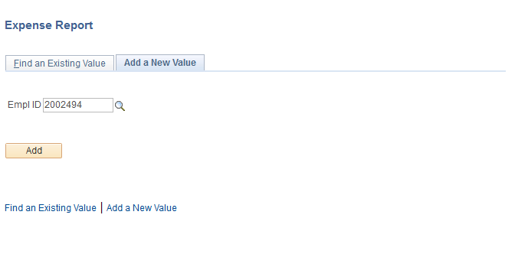
Click on the Find an Existing Value tab to find an existing Expense Report or click on the Add a New Value tab, enter your employee ID in the Emp ID field and click on Add to create a new expense report

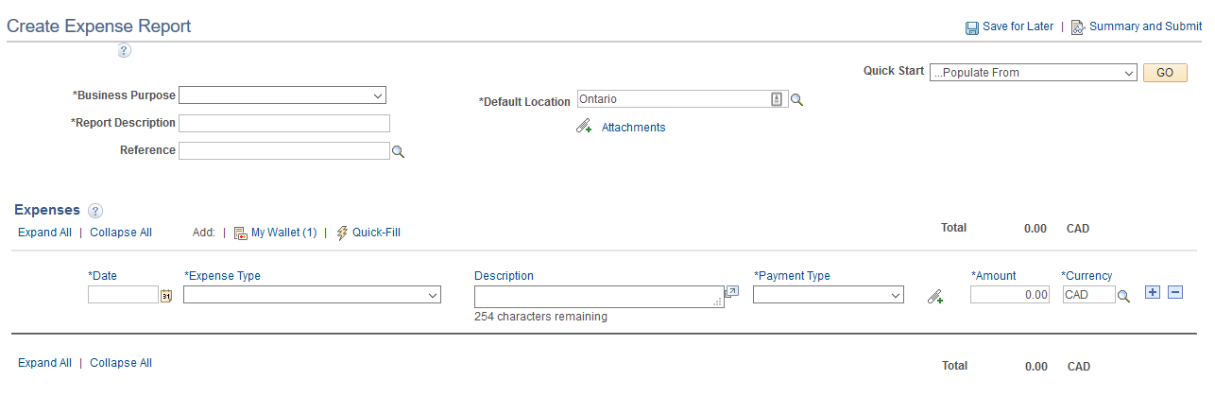

On this page you can:
- Add/remove an expense line
- Add corporate card transactions to the expense report from your wallet
- Attach receipts to your expense lines
- Enter the details of the expense
- Enter the accounting details

Items to Note:
- Any field with an asterisk (*) in front of it is a required field
- If entering a currency other CAD or USD, you will be required to enter the exchange rate for that currency
- Create additional expense lines using the + button
- Remove expense lines using the – button
- You can save your expense report and revisit it later by clicking the Save for Later button

Adding Out of Pocket Expense Lines

Depending on the Expense Type selected different options will display for you to fill out. Below are a few examples.

Accommodations

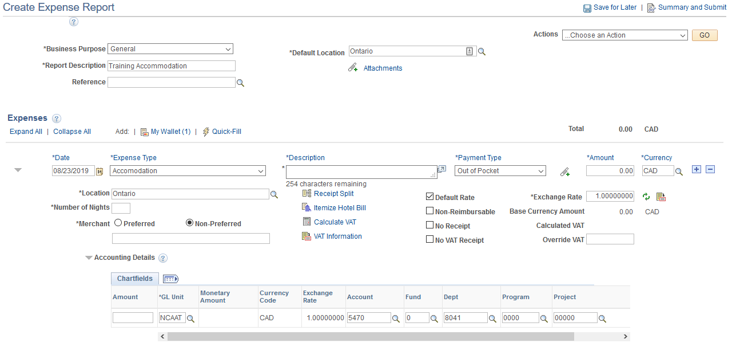
Mileage

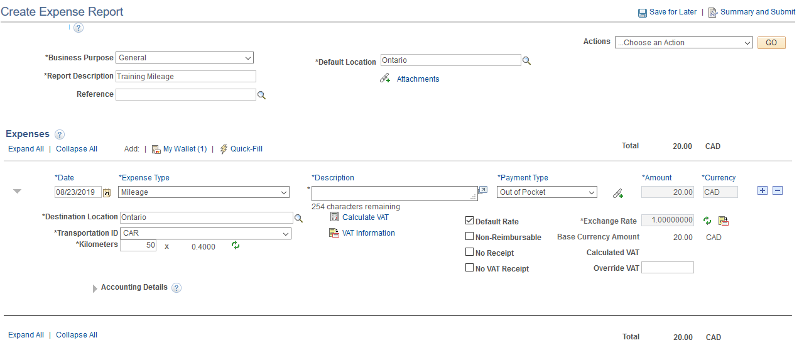

Note: Mileage rates are pre-defined in the system. Once you enter your travel distance in KMs, the system will automatically calculate the amount.

Per Diems

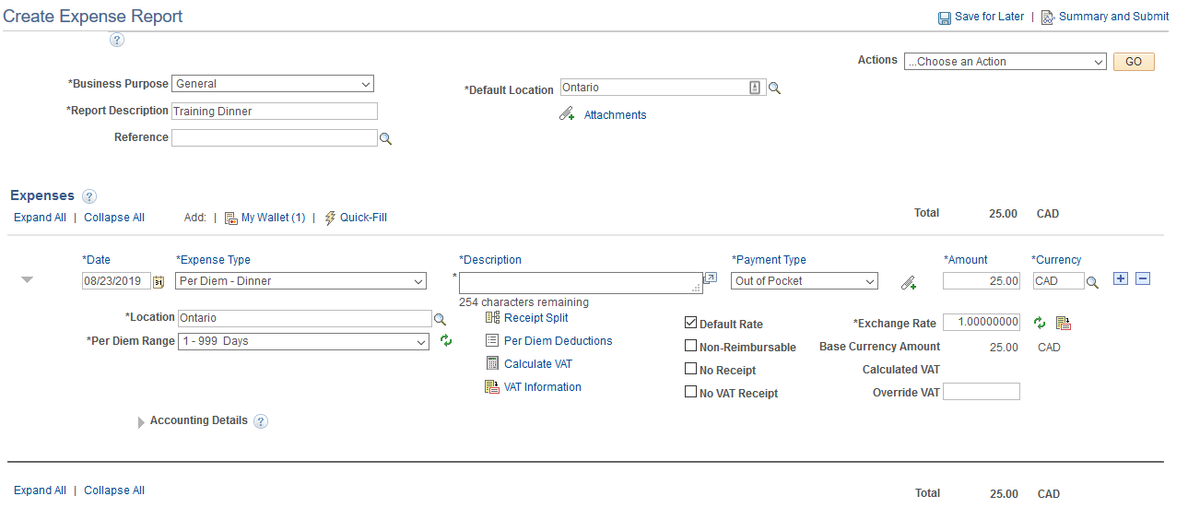

Note: Per Diem amounts are pre-defined in the system

Adding Corporate Card Transactions

Click on the My Wallet link to view the corporate card transactions in your wallet

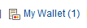

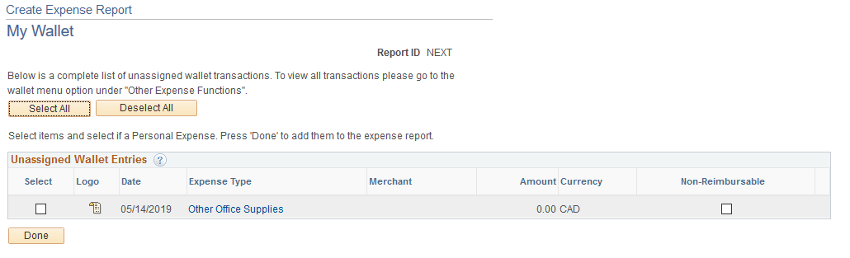

Click on the transaction you would like to add to your wallet, and you will then see the details of the transaction. On this page you are required to select an Expense Type from the drop down.

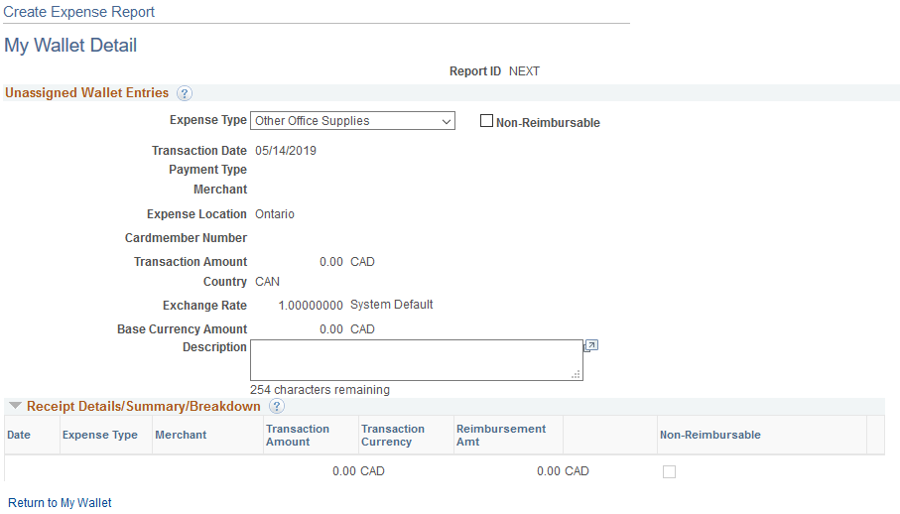

Once you have done this click Return to My Wallet. To add this transaction to your expense, select the checkbox beside the transaction and click Done. You will then be returned to your expense report with the transaction added as an expense line.

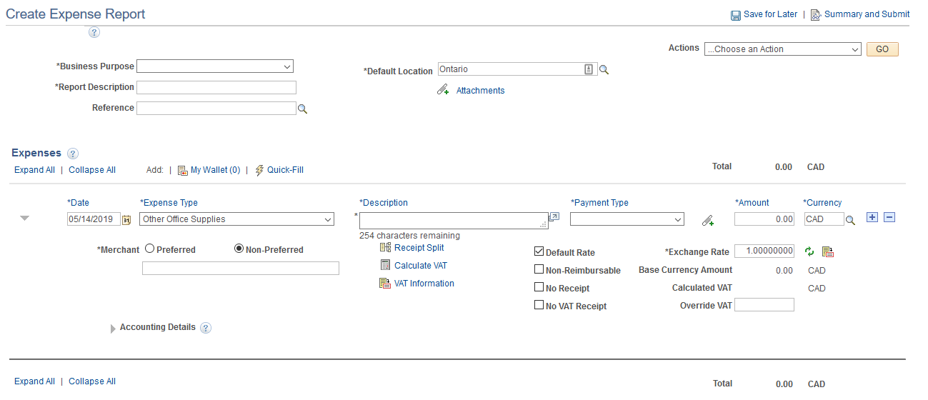

Associating a Travel Authorization

To link an approved travel authorization to your expense report, select Associate Travel Authorization from the Actions drop down and click Go.

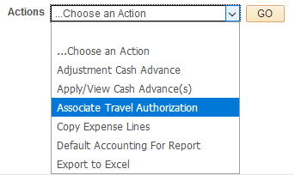

Applying a Cash Advance

To apply an approved cash advance to your expense report, select Apply/View Cash Advance(s) from the Actions drop down and click Go.

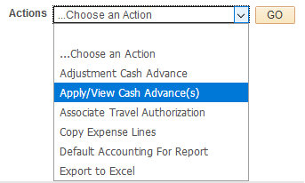

Submitting Your Expense Report

Once you have completed your expense report click Summary and Submit to review your expense report and submit it to your manager for approval.

When ready to submit your report, check off the checkbox agreeing that the information is accurate and complies with the expense policy and click Submit Expense Report.

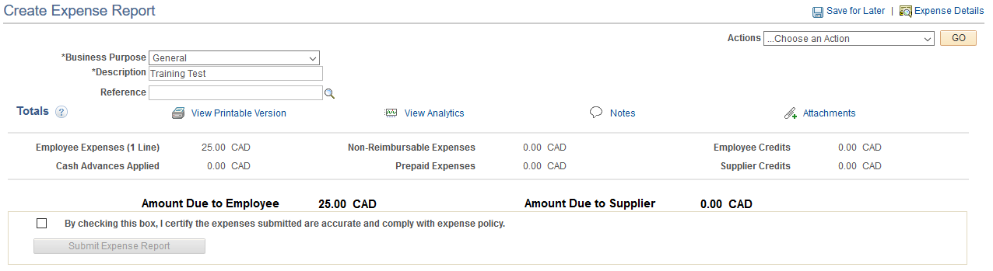
A final confirmation window will pop up where you can click Ok to submit the report or Cancel to return to the summary page. The report will then be routed to your manager for review.

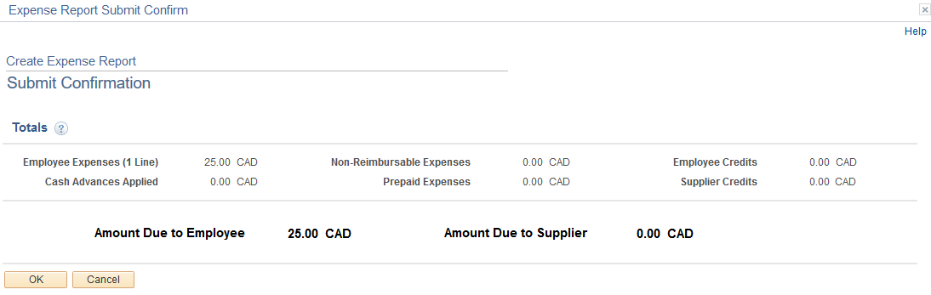

Travel Authorization – Traditional PeopleSoft Form

Click on the navigator icon, then follow the path:

Navigator -> Employee Self Service -> Travel and Expenses -> Travel Authorizations -> Create/Modify

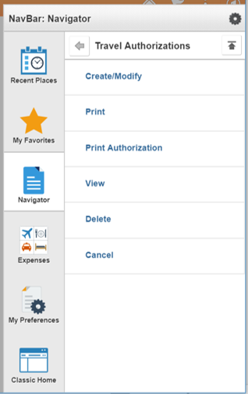

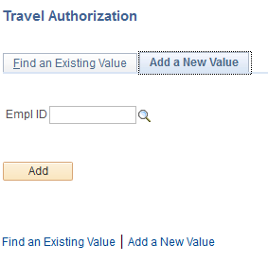

Click on the Find an Existing Value tab to find an existing Travel Authorization or click on the Add a New Value tab, enter your employee ID in the Emp ID field and click on Add to create a new Travel Authorization.

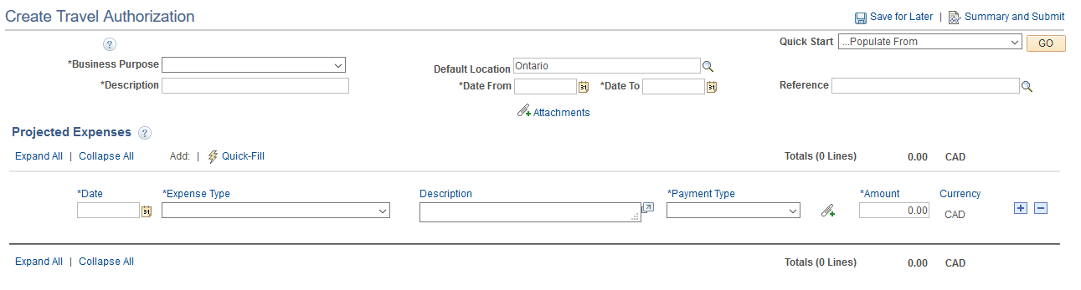

On this page you can:
- Enter the details of the Travel Authorization
- Enter the accounting details
- Attach supporting documents for your travel authorization
- Click on Summary and Submit for the Travel Authorization to be submitted

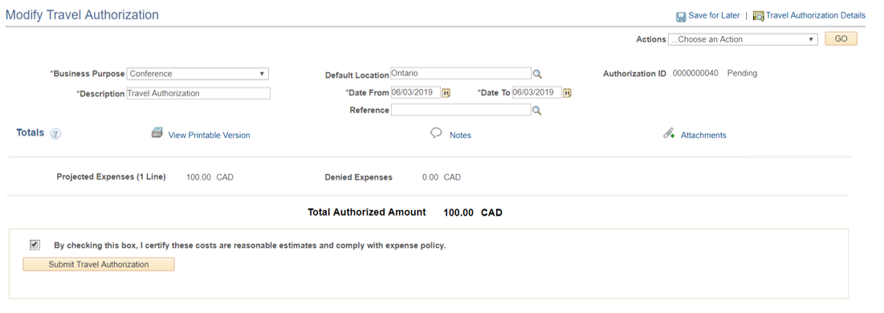

Flag the checkbox to accept the expense policy and click on Submit Travel Authorization

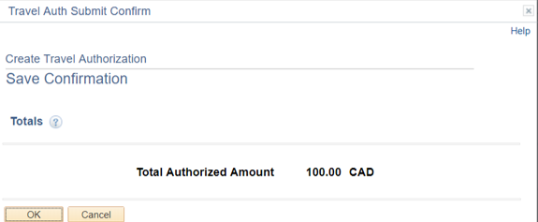

In the window that pops up check the details for accuracy and click Ok to submit the Travel Authorization to your manager for review.

Cash Advances – Traditional PeopleSoft Form

Click on the navigator icon, then follow the path:

Navigator -> Employee Self Service -> Travel and Expenses -> Cash Advances -> Create/Modify

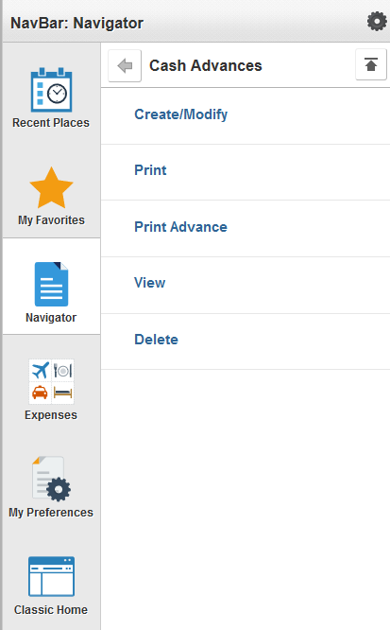

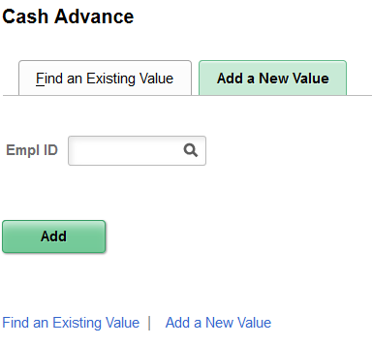

Click on the Find an Existing Value tab to find an existing Cash Advance or click on the Add a New Value tab, enter your employee ID in the Emp ID field and click on Add to create a new Cash Advance.

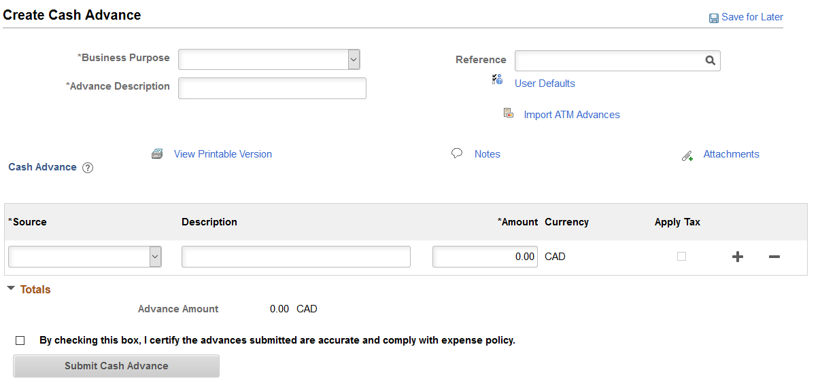
On this page you can:
- Enter the details of the Cash Advance
- Check the checkbox to agree with the expense policy and click on Submit Cash Advance

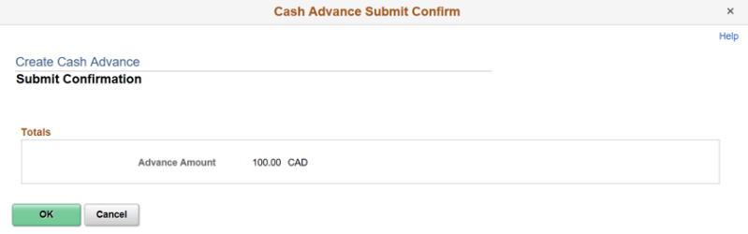

In the window that pops up check the details for accuracy and click Ok to submit the Cash Advance to your manager for review.

My Wallet – Traditional PeopleSoft Form

Click on the navigator icon, then follow the path:

Navigator -> Employee Self Service -> Travel and Expenses -> My Wallet

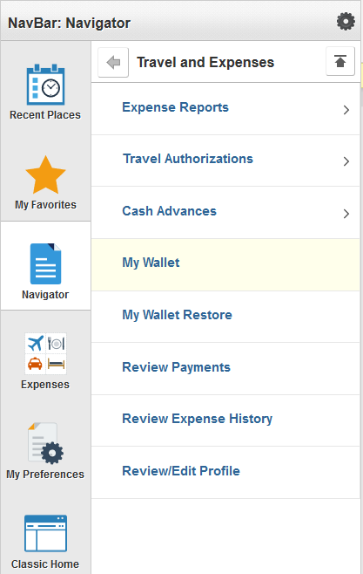

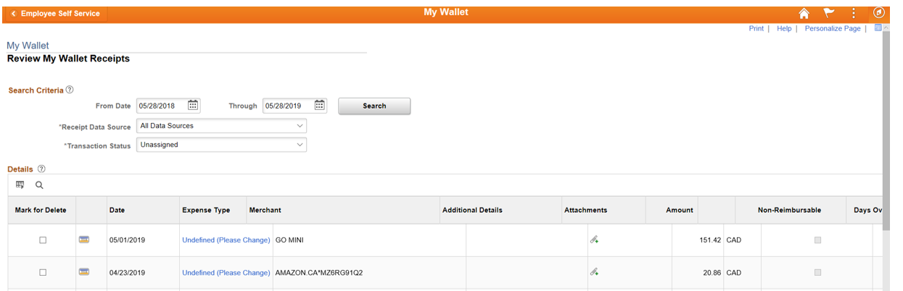

Use the search filters at the top to narrow down the list of transactions. Click on the transaction to view its details.

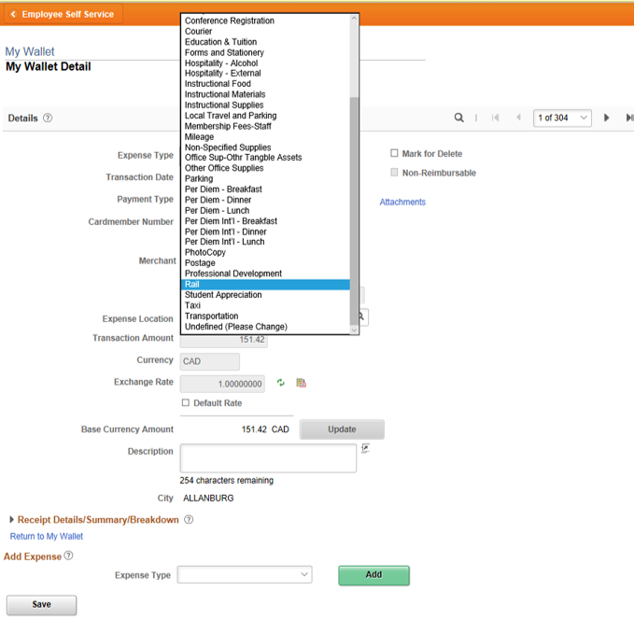

Select an Expense Type and enter a Description and click Save.

Viewing the Status of an Expense Report – Traditional PeopleSoft Form

Click on the navigator icon, then follow the path:

Navigator -> Employee Self Service -> Travel and Expenses -> Expense Reports -> Create/Modify

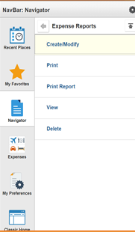

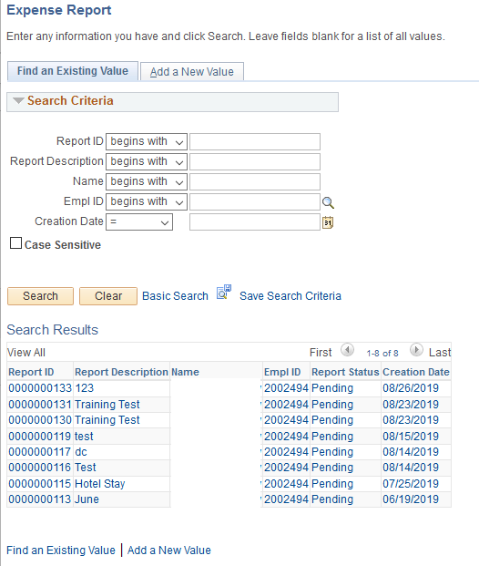

On the Find an Existing Value tab click search to see all your in-progress or submitted expense reports. Click on the report you wish to view

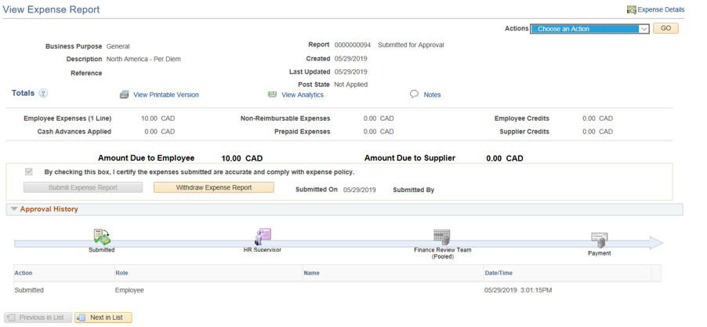

On this page you can view the status of the report and the different stages of the approval process. As well the employee can withdraw the expense report by clicking the Withdraw Expense Report button anything during the process before Approval.

Expense Report – Fluid Page

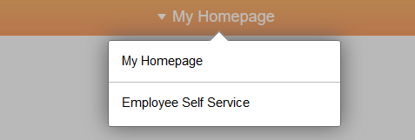

At the top of the screen click the down arrow beside My Homepage and in the drop-down list select Employee Self-Service.

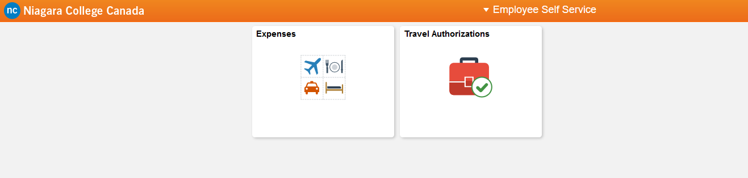

On the home page, click on the Expenses tile

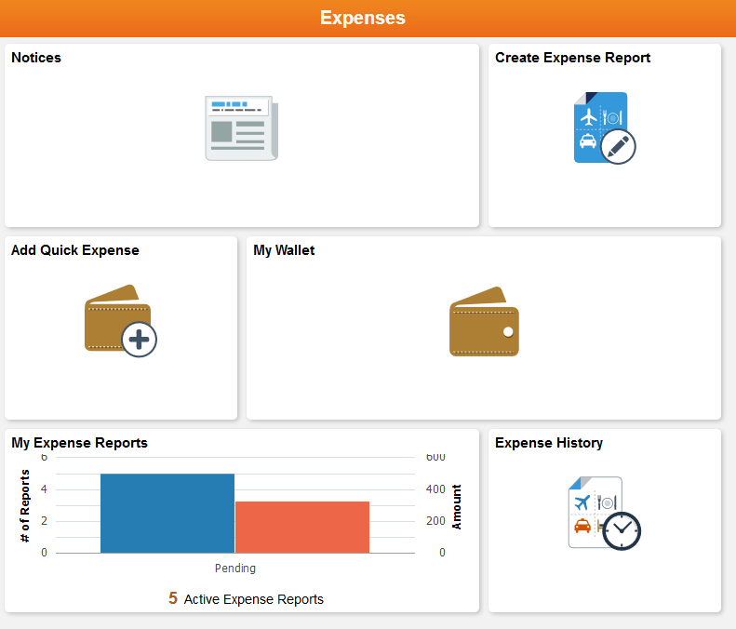

Click on the Create Expense Report tile to create a new expense report.

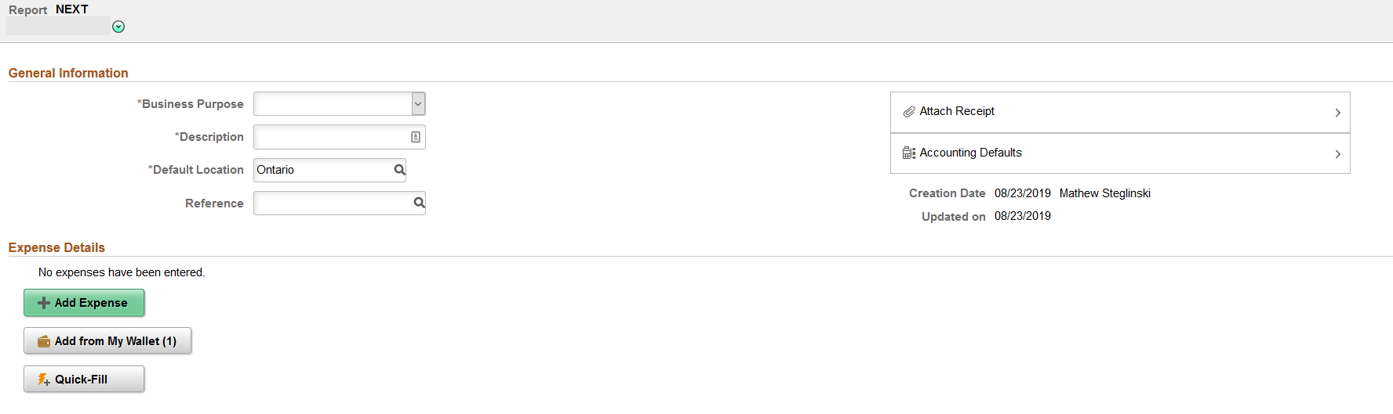

On this page you can:
- Add/remove an expense line
- Add corporate card transactions to the expense report from your wallet
- Attach receipts to your expense lines
- Enter the details of the expense
- Enter the accounting details

Items to Note:
- Any field with an asterisk (*) in front of it is a required field
- If entering a currency other CAD or USD, you will be required to enter the exchange rate for that currency.
- Create additional expense lines using the + button
- Remove expense lines using the – button
- You can save your expense report and revisit it later by clicking the Save button

Adding Out of Pocket Expense Lines

Click on the + Add Expense button to create a new expense line.

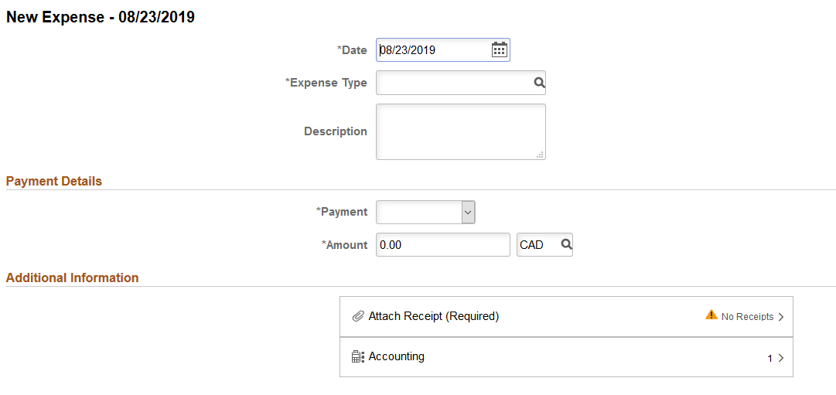

Depending on the Expense Type selected different options will display for you to fill out. Below are a few examples.

Accommodations

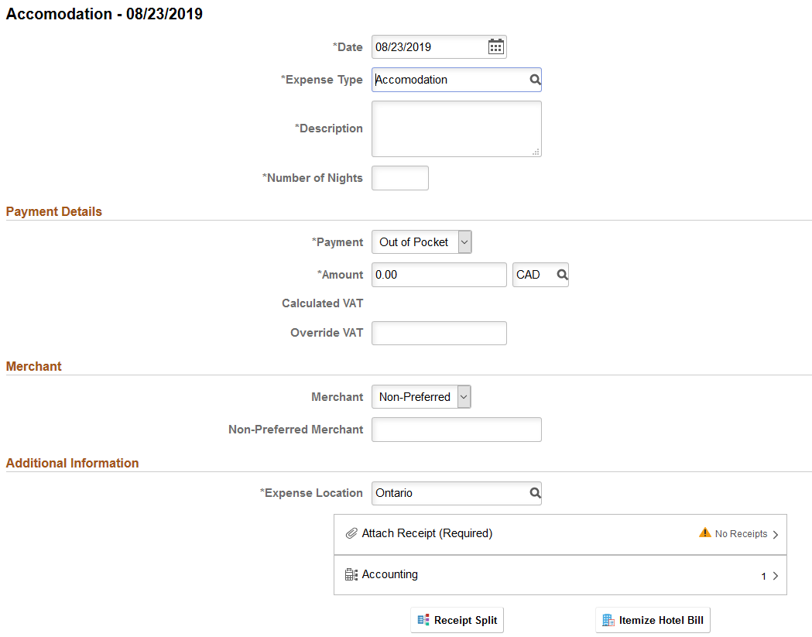

Mileage

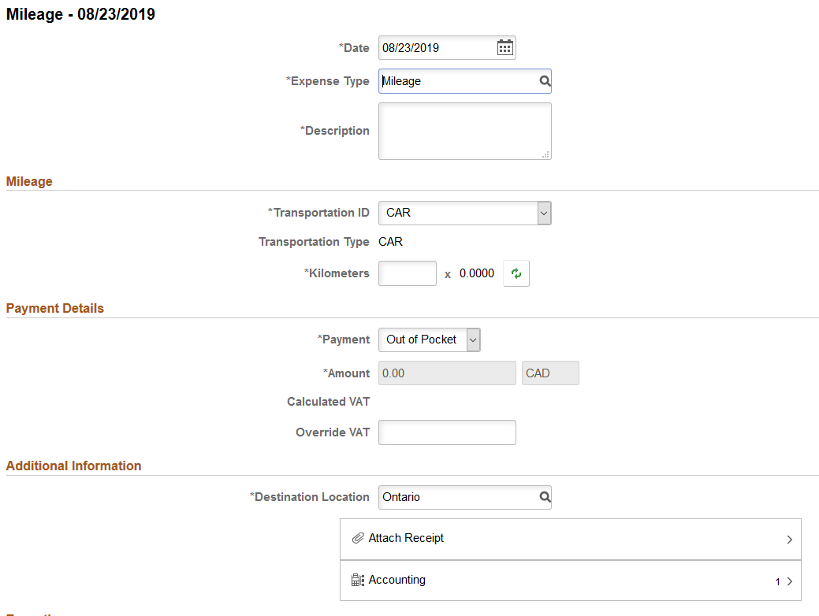

Note: Mileage rates are pre-defined in the system. Once you enter your travel distance in KMs, the system will automatically calculate the amount.

Per Diems

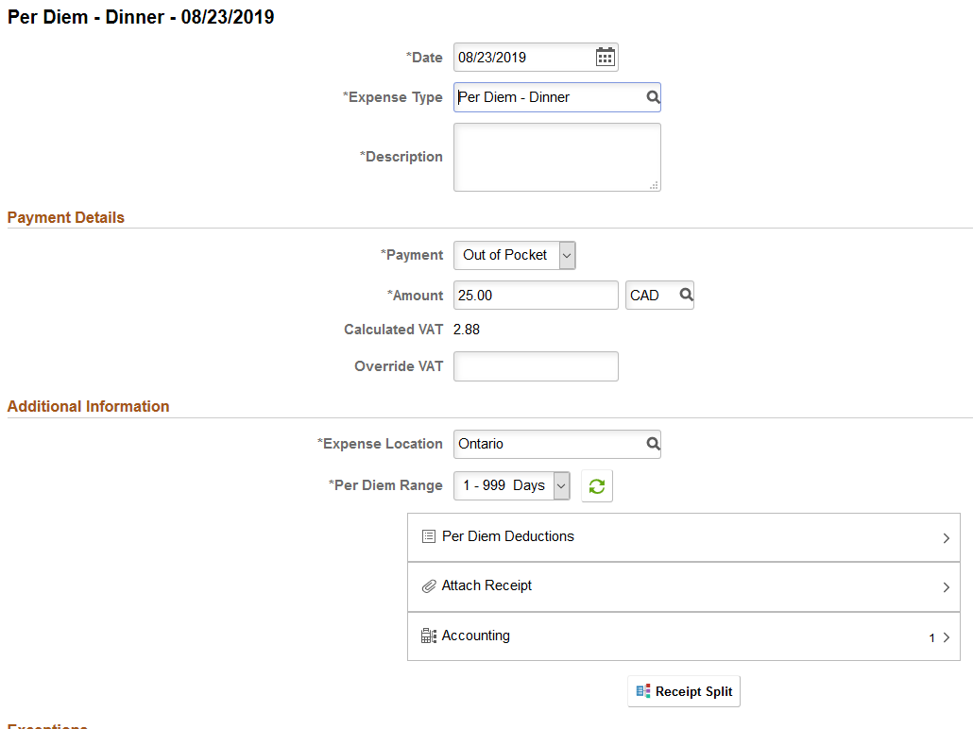

Note: Per Diem amounts are pre-defined in the system

Adding Corporate Card Transactions

Click on either the Wallet on or the Add from My Wallet icon to view the corporate card transactions in your wallet

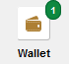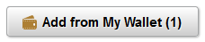

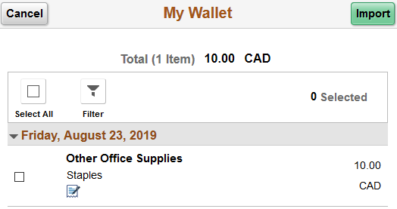

Click on the transaction you would like to add from your wallet and once it is selected click the Import button.

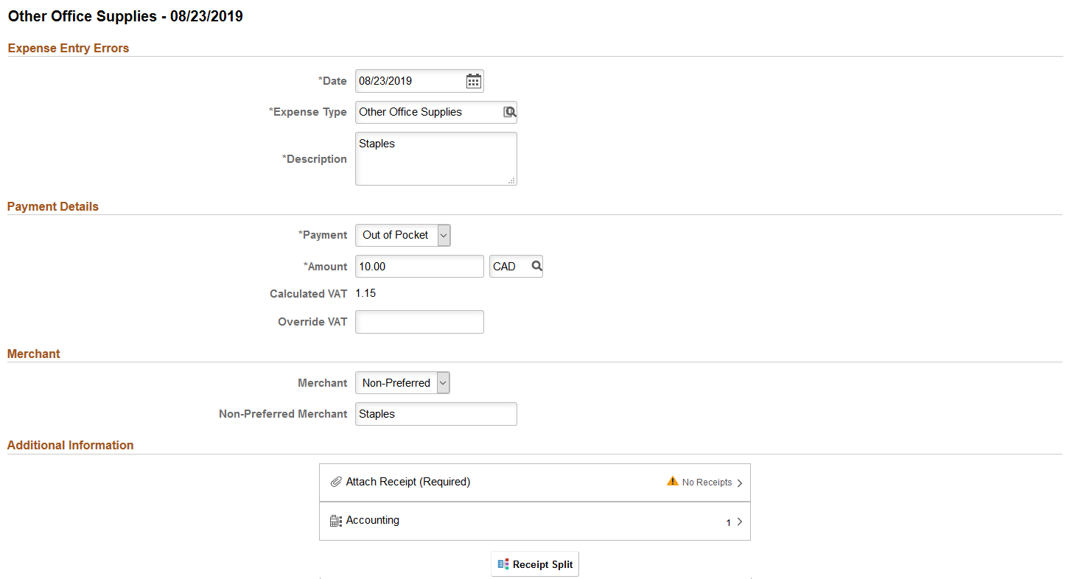

Associating a Travel Authorization

To link an approved travel authorization to your expense report, from the Expense Summary page select Travel Authorization.

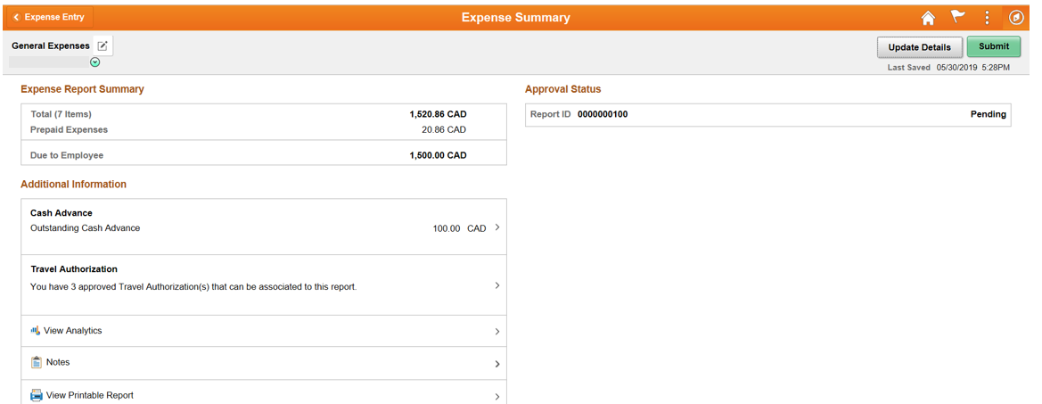

You will then see all your approved travel authorizations. Click Associate to apply the travel authorization.

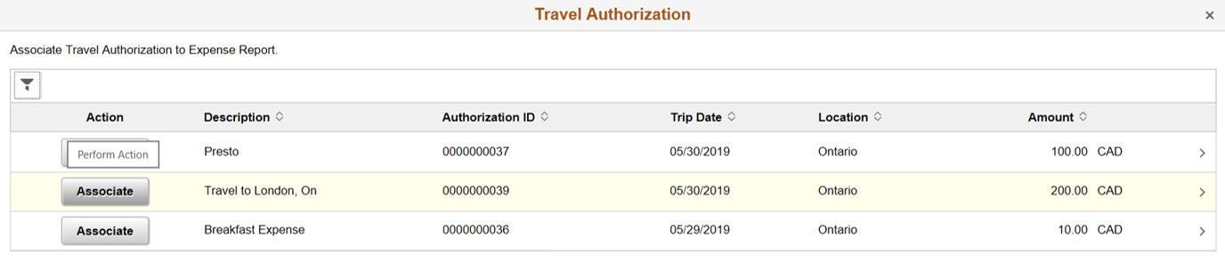

The travel authorization that was selected will now be associated to the Expense Report and shown on the page.

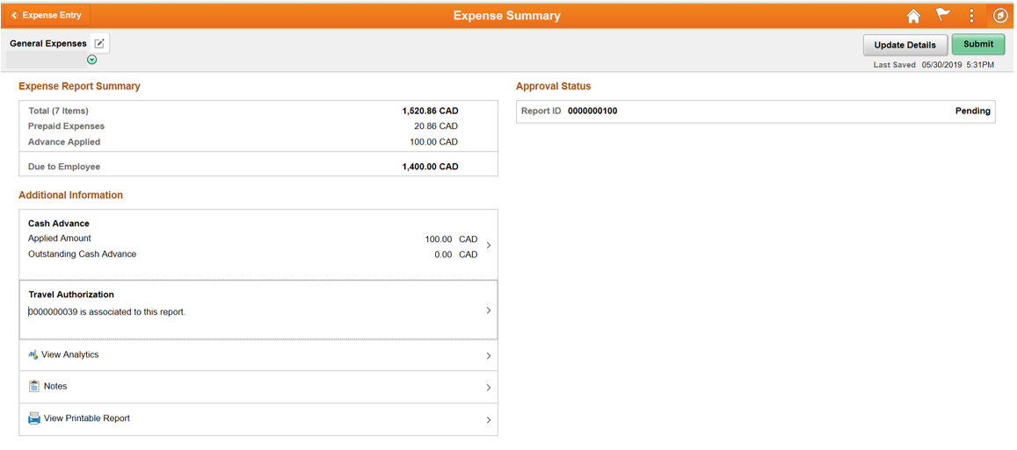

Applying a Cash Advance

To apply an approved cash advance to your expense report, from the Expense Summary page select Cash Advance.

You will then see all your approved cash advances. Select the row you would like to apply and enter the amount to be applied to the expense report and click Apply.

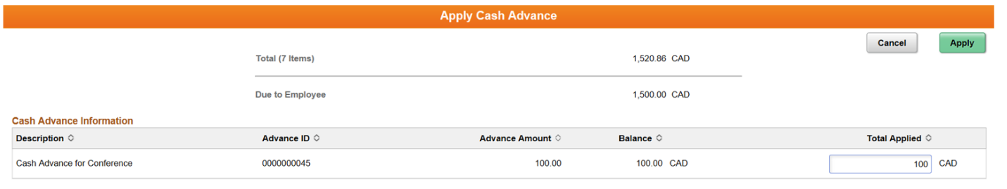

The cash advance amount that was entered will now be associated to the Expense Report and shown on the page.

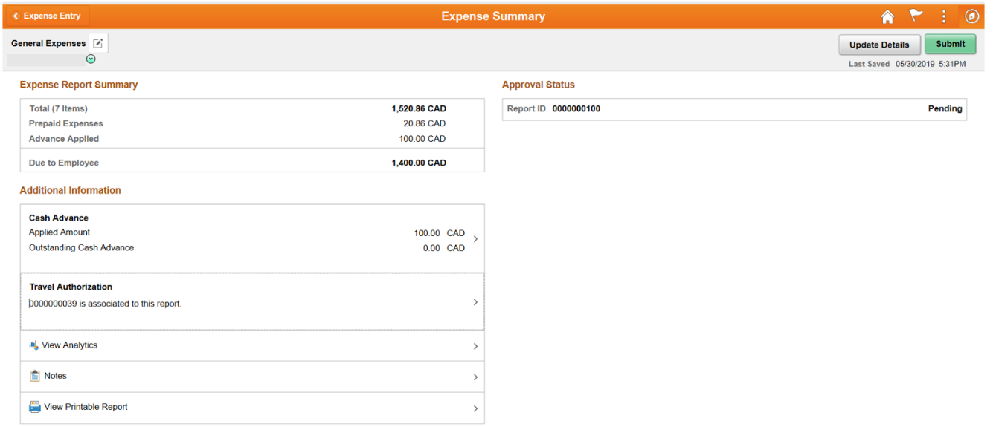

Submitting Your Expense Report

Once you have completed your expense report click Review and Submit to review your expense report and submit it to your manager for approval.

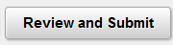

When ready to submit your report click Submit.

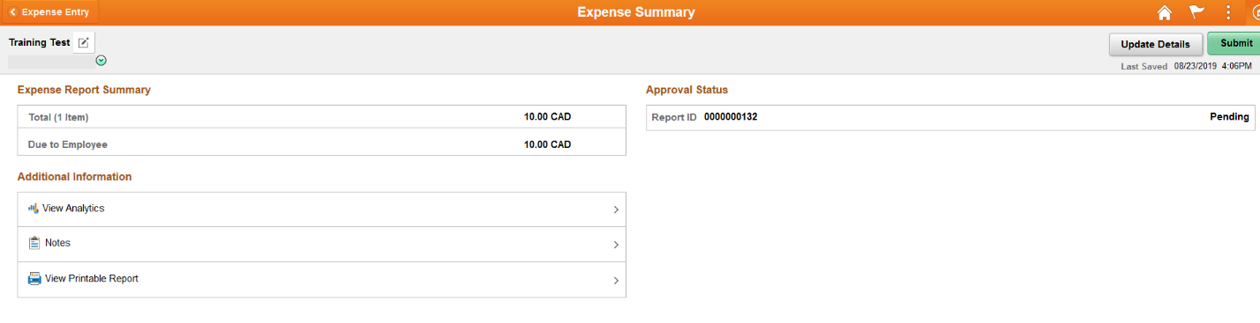

A window will pop up where you must acknowledge that the expense report you are submitting is accurate and complies with the expense policy.

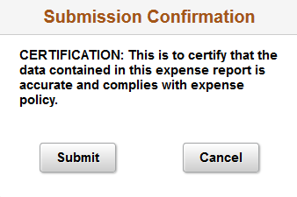

Click Submit to submit the report or Cancel to return to the summary page. The report will then be routed to your manager for review.

Travel Authorization – Fluid Page

To create a Travel Authorization, click on Travel Authorizations from the Home Page

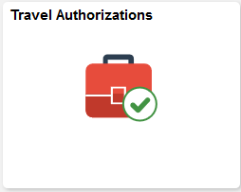

From this screen you can view the status of any previously submitted travel authorization or create a new travel authorization request by clicking Add Travel Authorization.

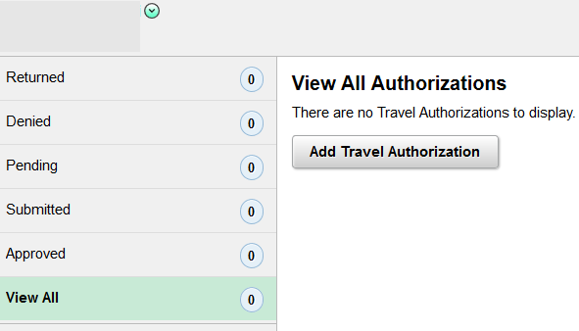

Enter the information for your trip including hotel, accommodation or hospitality expenses noting the required fields (Indicated by an asterisk *). When finished click Submit.

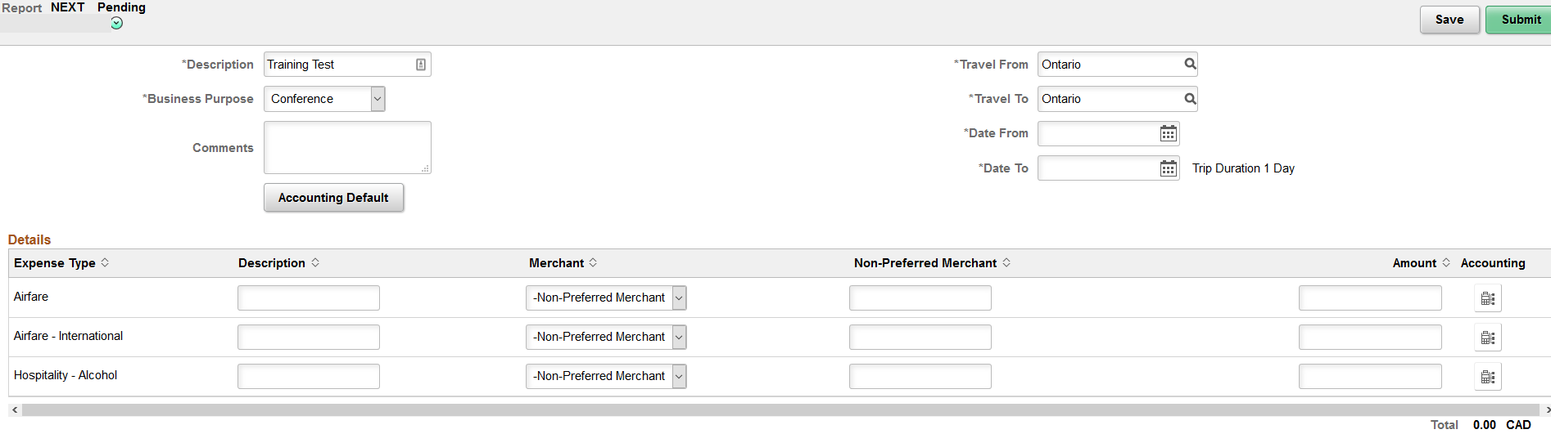

My Wallet – Fluid Page

To review your corporate card transactions and assign an Expense Type click on the My Wallet tile from the Expenses home page.

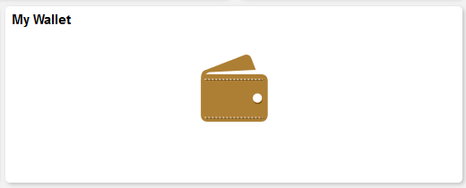

On the left-hand side of the page will be all the corporate card transactions linked to your card. Click on the transaction you would like to update, and its information will appear in the main window.

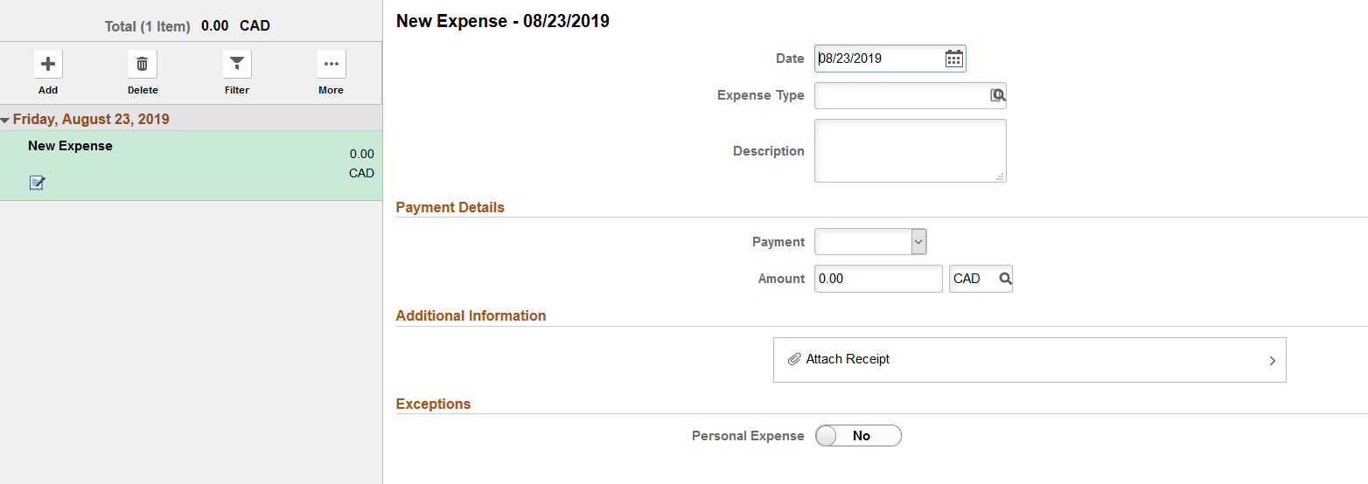

An Expense Type and Description are required to be entered in order to process your transactions. Enter these in and click Save.

Viewing the Status of an Expense Report – Fluid Page

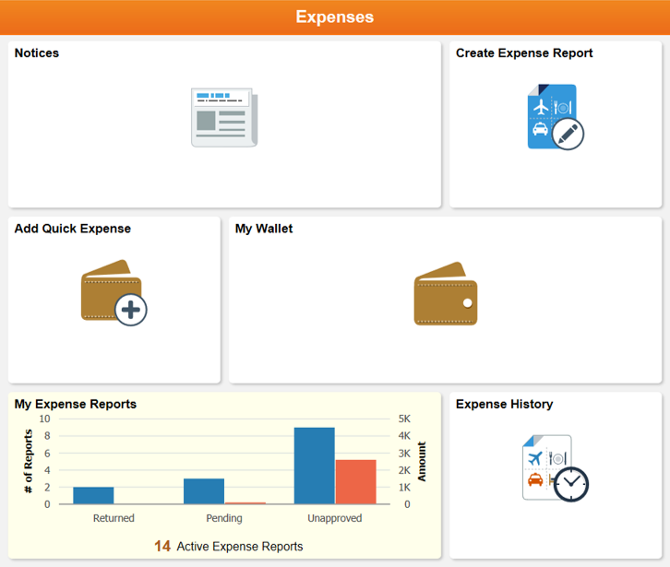

To view your in-progress of submitted Expense reports, click on the My Expense Reports tile from the Expenses home page.
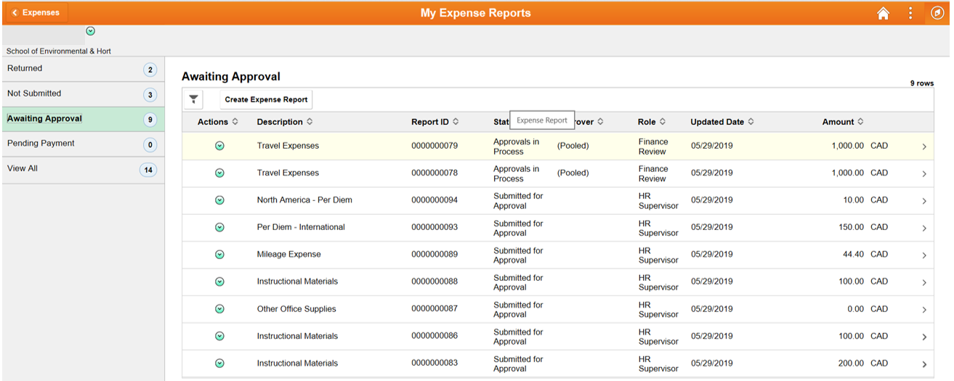

On the left-hand side, you can choose to filter based on the status of the Expense Report. To view the details of a report, click on the Expense Report in the main window.

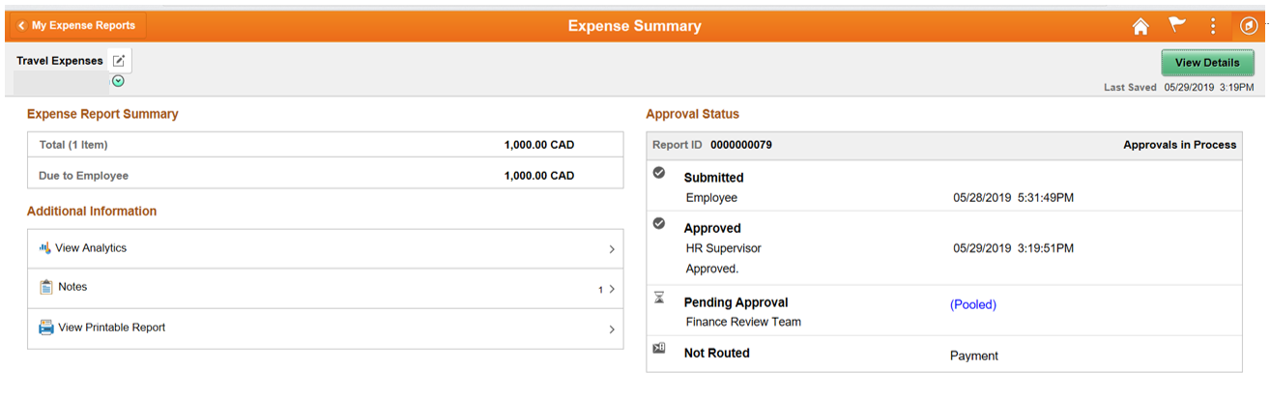
A summary of the Expense Report will be shown as well as the current approval status amongst the different stages of the process. To view the details of the report, click on View Details.

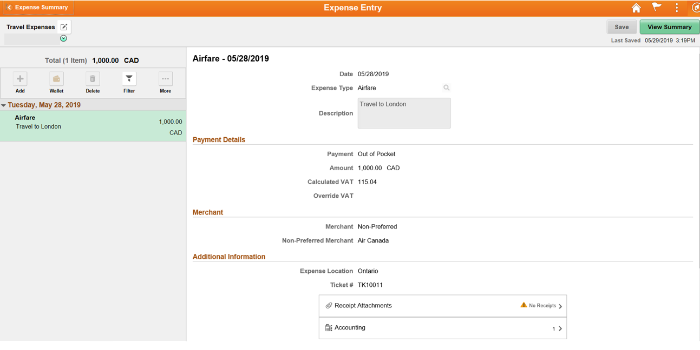

Adding Travel and Expense Link to Mobile Home Screen

Follow the instructions below to add a shortcut to the Travel and Expense module on the home screen of your iOS or Android devices.

iOS

- Launch Safari. (This will only work through the Safari browser)
- Login to the MyNC portal (https://portalnc.niagaracollege.ca) and open Oracle - Financials
- Tap the share icon (An arrow coming out of a box) from the bottom of your Safari window

- In the window that pops up, scroll down and select Add to Home Screen. The Add to Home dialog box will appear, with the icon that will be used for this website on the left side of the dialog box
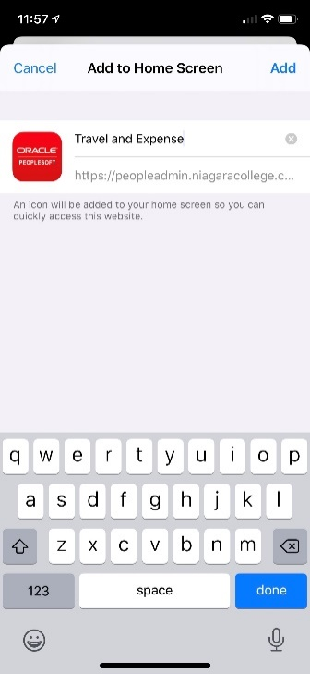
- Enter the name for the shortcut using the on-screen keyboard and tap Add. Safari will close automatically, and you will be taken to where the icon is located on your home screen

Android

- Launch the Chrome app
- Login to the MyNC portal (https://portalnc.niagaracollege.ca) and open Oracle - Financials
- Tap the menu icon (3 dots in upper right-hand corner) and select Add to Home Screen
- Enter a name for the shortcut and then Chrome will add it to your home screen

