

Niagara College
Training Manual – PBCS NC Budget Module

Table of Contents

Introduction to PBCS 3
What is PBCS? 3
PBCS and Dimensions 3
PBCS Dimensions at Niagara College 3
Accessing PBCS 4
Home Page Overview 5
Setting PBCS Preferences 7
User Preferences 7
Navigating Forms 10
Changing Point of View 10
Entering Data 12
Entering Comments 12
Budget Development 13
Workforce Planning 13
Workforce Data 13
Full-Time Workforce 14
Full-Time Position Info 14
Full-Time Allocations 17
FT Position Review 18
Position Allocation Review 18
Salary Adjustments Review 18
Part-Time Workforce 19
Part-Time Admin and Support Staff 19
Part-Time Faculty 20
Part-Time Students 22
Capital Expenditure Requests 23
CapEx Request 23
Create a Request 23
Viewing Approved Requests 24
Tracking Capital Allocation 24
Budget Request 26
Budget Request Form 26
Viewing Divisional Allocation 28
Submitting the Budget 29
Running Reports 32

Introduction to PBCS

What is PBCS?

Oracle Planning and Budgeting Cloud Service (PBCS) is a web-based planning solution that drives collaborative, event-based planning and forecasting models.

PBCS is an all-in-one tool for the end-to-end and closed-loop planning process that drives continuous business improvement.

PBCS provides the ability for all front-line managers to communicate the appropriate course of action to take and allows the budget holders to collaborate so that the planning process is streamlined and efficient.

PBCS and Dimensions

PBCS is a multidimensional database server optimized for planning, analysis and management reporting applications. PBCS utilizes dimensional hierarchies and consolidates data. Plan data entered into the application is then stored in a multidimensional database.

Dimensions are the actual descriptors of the base elements that describe and store data. Years, Scenario, Departments, Programs and Accounts are all examples of dimensions.

Within each dimension, the individual elements are called members.

PBCS Dimensions at Niagara College

Dimension | Purpose
Account | Based on the Chart of Accounts from PeopleSoft, as well as drivers and statistical accounts
Department | Contains the hierarchy for Divisions and Departments
Fund | Distinguishes the fund. There is currently only one fund
Period | Specifies the periods of the fiscal year or academic terms such as months, quarter and total year
Position | Used to capture Employee and Position information
Program | Defines Academic and Non-Academic Programs
Project | Defines the project
Scenario | Specifies a data classification:  - Actual – actual data loaded from PeopleSoft  - Budget – Reflects budget or inputs from users  - Forecast – Corresponds to predictions for upcoming periods
Version | To allow multiple iterations of a plan, modeling possible outcomes, managing dissemination of data and facilitating target setting
Years | Corresponds to the fiscal year

Accessing PBCS

Planning and Budgeting is cloud-based and can be accessed via any computer with internet access.

PBCS can be accessed through the Niagara College portal:

https://portalnc.niagaracollege.ca/

Login to the Portal using your Niagara College credentials and click on the More Applications icon at the top:



Expand the All link and click on the PBCS icon - If you would like to favorite the link to appear on your home page, select the star:

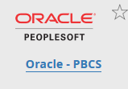

This will take you directly to the application Home Page.

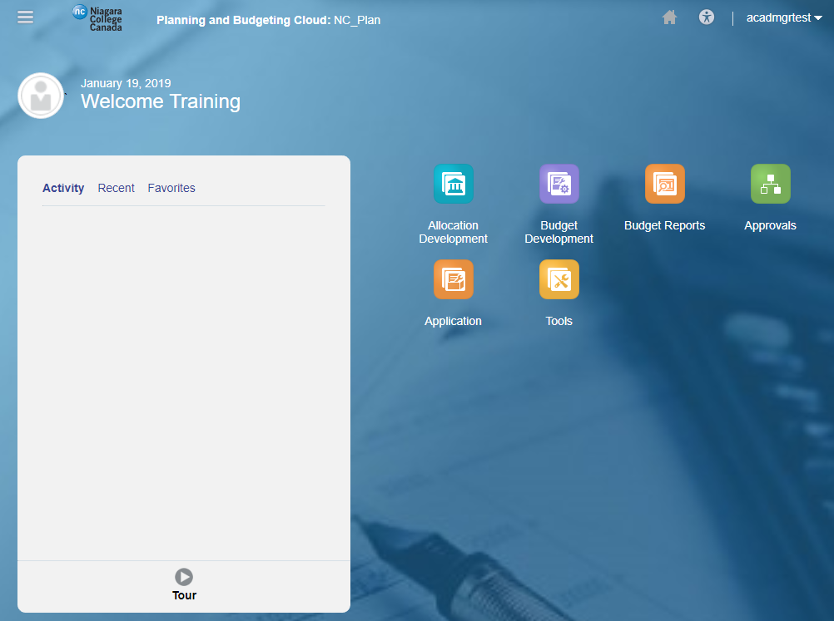

Home Page Overview

The navigation flow is made up of clusters and cards:

- Cards represent the different objects in Planning and Budgeting, such as forms, reports, and dashboards.
- Clusters are a grouping of cards. Each cluster groups like business processes.

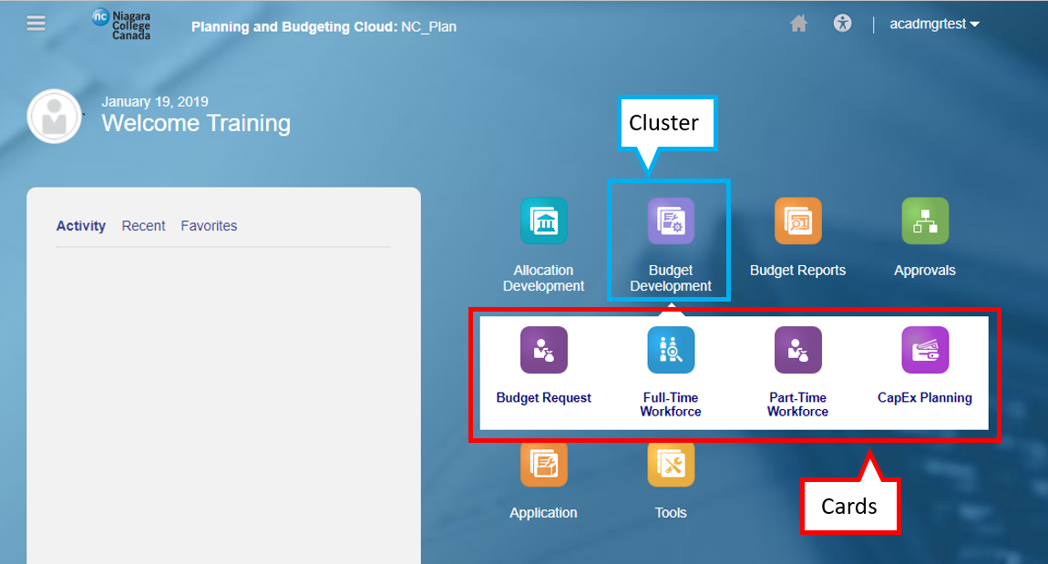

You may return to the home page by:

- Clicking the Niagara College logo
- Clicking Home

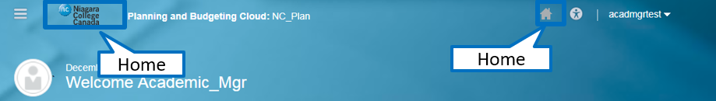

The Navigator shows all forms, tools, and preferences available within Planning and Budgeting.

- While you have access to Navigator, it is recommended you use the navigation flows to carry out all budgeting tasks.

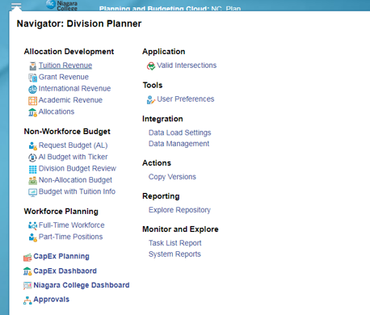

The Activity Pane shows a list of recent activity and favorited objects. To favorite an object, click on the star icon.

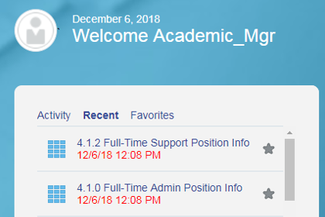

Setting PBCS Preferences

To access Preferences, click the Tools cluster, then select the User Preferences card.

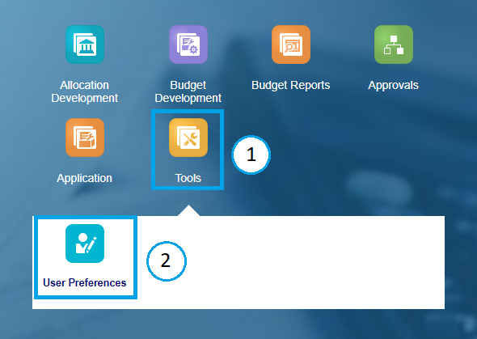

User Preferences

Note: While there are many Preference options, generally you can choose the Administrator’s Settings for Application Defaults. However, these are some recommended user specific settings;

- General – Set time zone to Eastern Standard Time and select Use Administrator’s Settings under Alias Setting and Approvals

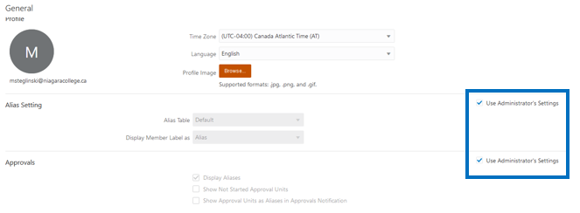

- Display – Select Use Administrator’s Settings under Number Formatting, Page Options and Other Options

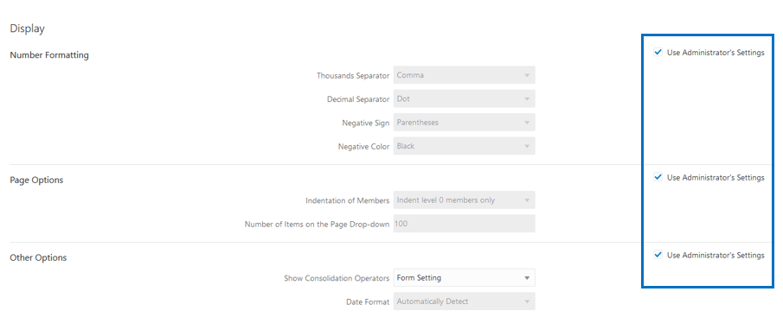

- Notifications – Enter your e-mail address and select Use Administrator’s Settings to receive system notifications

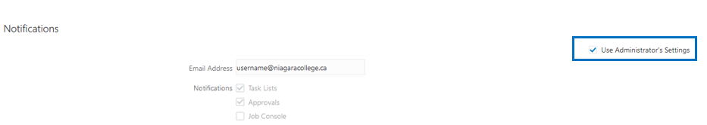

- User Variables – Act as filters in forms, enabling users to only see data and information that are relevant to them.

- When you open a form, the members you set as user variables will already be set in the form.

User variables only need to be set once, but they can be changed at any time. Members can be selected for each dimension by clicking Member Selector.

Recommend Settings;
- BA_Department: Select the Division that contains the Cost Centers you submit
- BA_DivisionAllocation: Select the Division that contains the Cost Centers you submit
- BA_Program: Select the Programs associated with the Departments you budget. If you are part of a non-academic division, select the default program budget - 0000
- BA_ Project: Select the Projects associated with the Departments you budget
- Fund: Select ‘Fund 1’

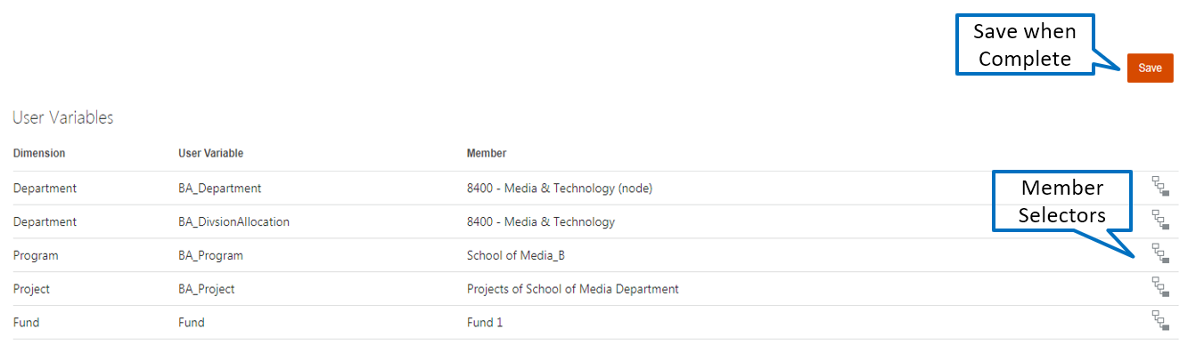

Members can be selected in two ways from the Member Selection window:

- Key in a value on the Search Bar
- Select from Hierarchy and check the member. For all selections click just to the left of the member until a check mark appears

With either method you can confirm your selection at the top left portion of the window before clicking OK.

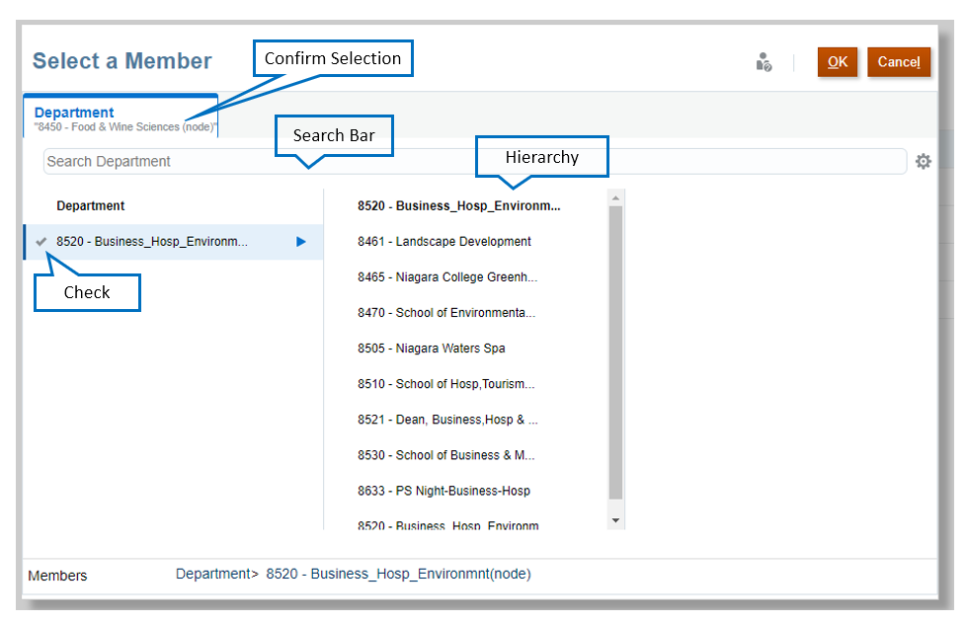

Navigating Forms

Forms in Planning and Budgeting have the following structure:

- The navigation toolbar allows you to navigate to the other cards in that cluster.
- The Point of View (POV) defines the section of data in the Planning and Budgeting database you are viewing. You select the desired members for each dimension to determine the context for the pages, rows, and columns. NOTE: The default POV is defined by the user variables you set.

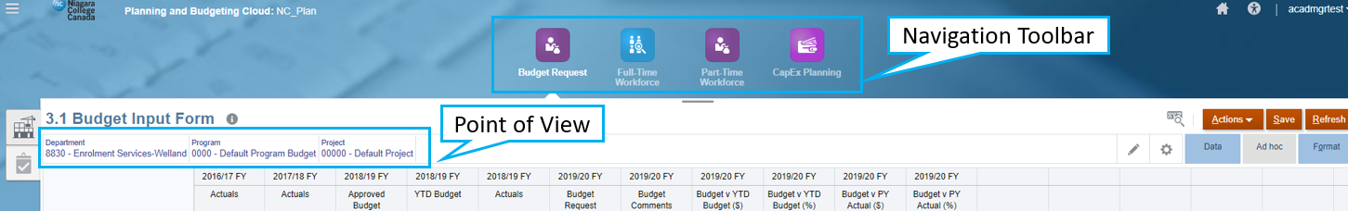

Changing Point of View

- To select the POV, click Edit Members. The Edit Members window is displayed.
- To select different members for the dimension, click the dropdown next to each dimension. Select the desired member from the list of available members.

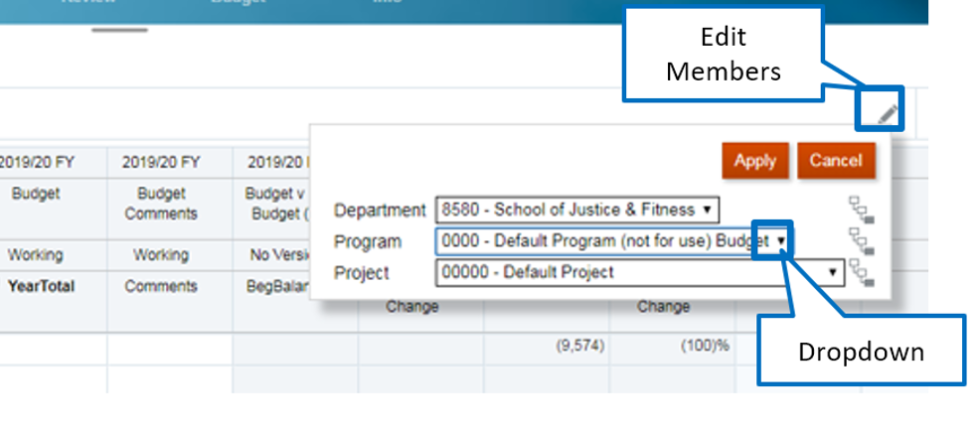

- Once the desired member is selected, click Apply.

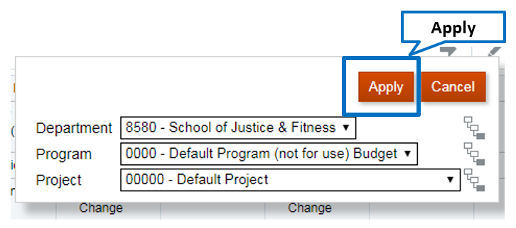
Alternatively, members can be selected for each dimension by clicking Member Selector

In the member selector, a selection can be made in two ways:

- Type the member in the Search Bar
- Drill through the hierarchy and check the member desired
  - Select the triangle at the right of a member expands the hierarchy across the screen
  - Select a member by clicking just to the left of the member and a blue check mark will appear

In either case confirm the selection at the top left of the screen and click OK

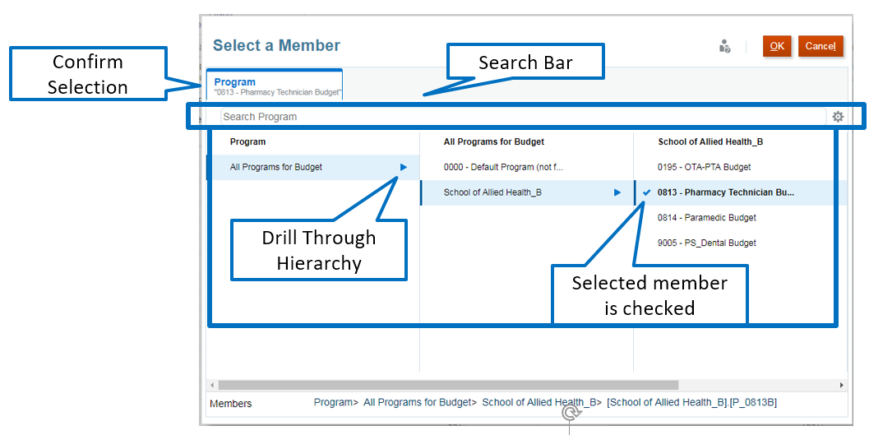

Once you return to the form you will see the member you edited highlighted in yellow indicating a change has been made but not actioned. Click the arrow to update the form with your POV selection.

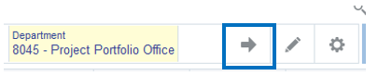

Entering Data

Cells display the data for the selected members. Cell colors indicate the cell’s status:

- White: default; data can be entered into these cells
- Yellow: values changed but data is not yet saved
- Grey: read-only cells
- Grey with a Lock Symbol: locked cells
- Teal: cells have supporting detail

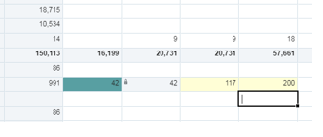

Entering Comments

To add or view comments:

- Right-click on desired input cell
- Click Comments
- A small window will pop up. If existing comments have been you will see them here
- Enter comments and click Post
- Cells with comments will have a black corner
- To delete a comment, click on the Delete link that appears in the comments pop up window

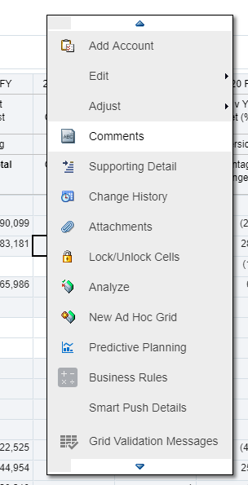 | 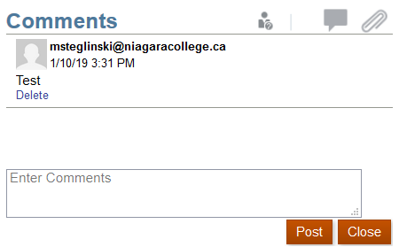

Budget Development

Workforce Planning

The forms available for workforce planning are:

Category | Type | Forms for each Type | Planned by
Full-Time | - Faculty  - Admin  - Support | - Position Info – Change Existing Employee Information, Add New Positions  - Allocations – Allocate total employee salary to programs and projects  - Position Review | Employee Level
Part-Time | - Admin  - Support  - Faculty  - Student | - One form to plan by Department, Program and Project | Department/Program/Project/Term

Access Workforce Forms from the Budget Development cluster on the PBCS Home Page:

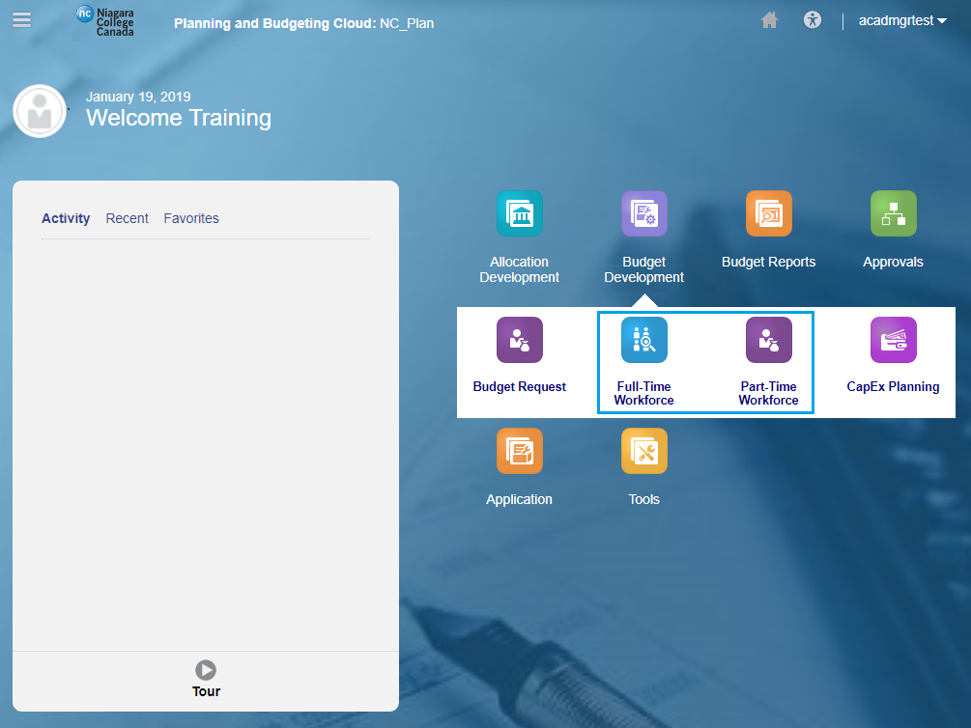

Workforce Data

Full-Time
- All data is pre-populated with current salary information based on all know contractual increases for the upcoming budget year for each job classification.
Part-Time
- Part-Time Admin, Support Staff and Student data will be rolled over the previous years approved budget
- Part-Time Faculty data will be populated from AMPS, with the ability to add any budget data that is typically planned for outside of AMPS.

Full-Time Workforce

The purpose of these forms is to track and allocate FT salaries to applicable budgets by job classification. Once this schedule has been completed the total by Department, Program and Project will automatically link to the Budget Request form.

Access the Full-Time forms as shown below:

Note: The Faculty, Admin and Support Staff are identical in look and functionality.

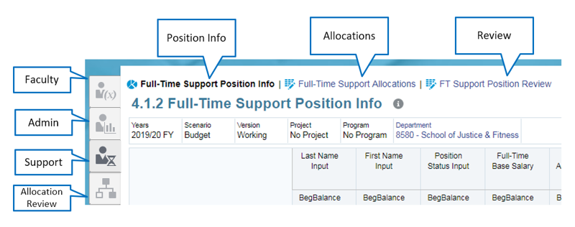

Full-Time Position Info

This form will display the list of employees within your division under the selected job classification.

- The total by Dept, Program and/or Project is provided on the FT Position Review form
- If a specific individual’s budget is greater or less than 100% it will appear highlighted in red on the Allocation Review form

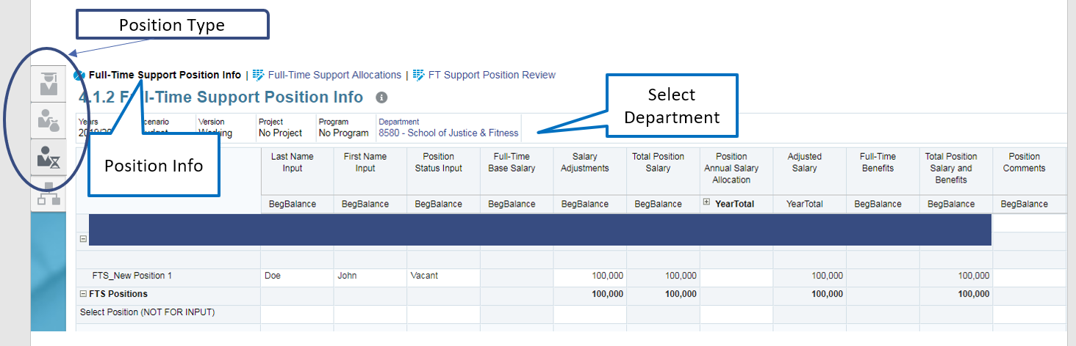

On this form you can:

- Make changes, if necessary, to the following fields:
  - Employee First/Last Name
  - Position Status – Filled or Vacant
  - Salary Adjustments – Adjustments to total annual salary

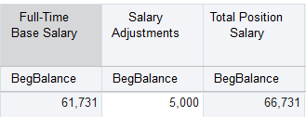

  - Position Annual Salary Allocation
    - Expand the column down to the individual months by first clicking the + beside YearTotal and again for each Quarter
    - If the cell has 100% the application assumes that an employee is full-time for all months throughout the year
    - Enter a number between 0 and 1 by month to allocate a portion of total salary to a month (0.5 would equal 50%)
    - Use this to allocate salary to months throughout the year for:
      - New hires that start mid-year
      - Planned mid-year terminations
      - Less than full-time for certain months

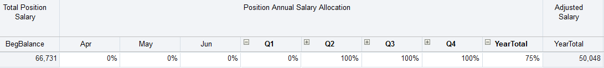

  - Position Comments – Add any relevant notes related to the employee
  - View the positions Home Department
- Add new full-time positions (Please consult the Finance Office before adding a new position as the required approvals must be obtained outside of the system)
  - Scroll down to the bottom of the form and click on the Select Position field
  - Select a new Position Number from the drop down
  - Please Note: The Position Number does not auto populate. Make sure that you pick the next available position number. In picture FTA_New Position 1 has already been selected so be sure to pick number 2
  - Fill in all relevant fields related to this position
  - Click Save when completed

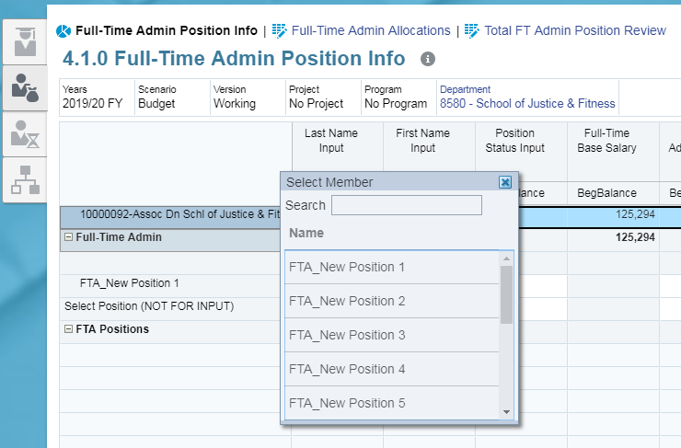

- When changes are saved, the following fields are calculated based on the changes:
  - Total Position Salary
  - Position Annual Salary Allocation
  - Adjusted Salary
  - Full-Time Benefits
  - Total Position Salary and Benefits

Save Button, top right corner of form

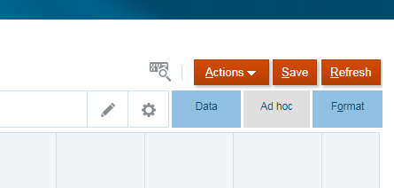

Full-Time Allocations

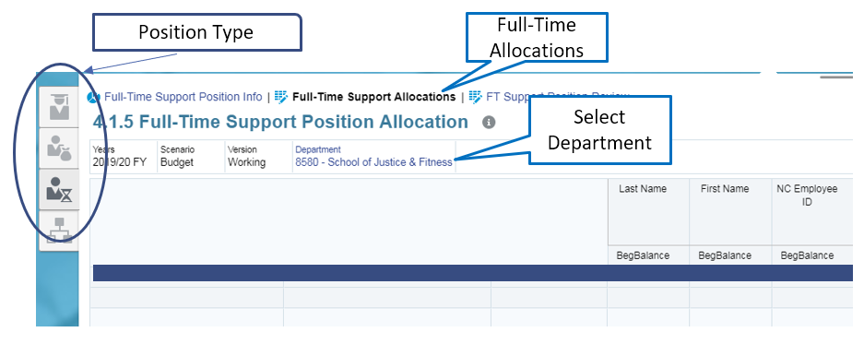

This form will display all of the employees from the Position Info form and the respective programs and projects they are budgeted to.

On this form you can:

- Adjust existing splits by updating percentages in Budgeted % of Total Salary in CFS
- Initiate a new split to allocate a position across departments/programs/projects
  - To initiate a split right-click on the desired position and select Split Position CFS
  - A new window will pop up
  - Current position Department, Program, and Project are listed on the left side of this box
  - New or target values can be selected on the right side of the box.
  - Select the percent to be allocated to the target destination by entering a value between 0 and 100 in the “Budgeted Percent in CFS” box
  - Select the Launch button at the top of this box to calculate the allocation
  - Select the Save button at the top right of the form to save changes

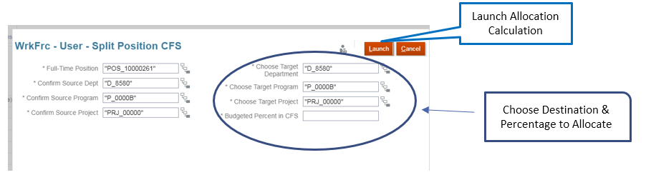

FT Position Review

The purpose of this form is to summarize all employee salaries and benefits across each of the unique chartfields that were allocated to.

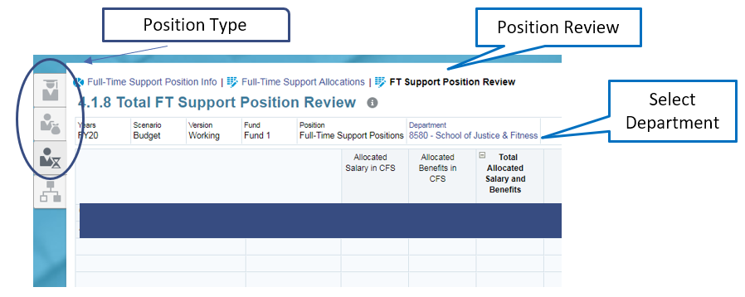

Position Allocation Review

The purpose of this form is to display the percentage allocation by position. Any positions allocated more than 100% will be highlighted in red and should be addressed by returning to the allocation forms and adjusting. Positions allocated to multiple departments will show as red when only selecting one department in the POV. A final review can be completed by the Dean/Director prior to submission by selecting the Division in the POV to ensure all employees in their division are allocated 100%

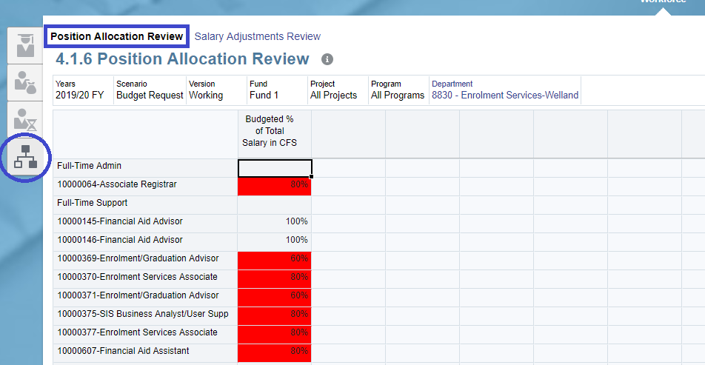

Salary Adjustments Review

The purpose of this form is to display any differences in annual salary or monthly allocation when a position has been split across departments. Any positions with a different annual salary or monthly allocation across departments will be highlighted in red and should be addressed by returning to the position info forms and adjusting.

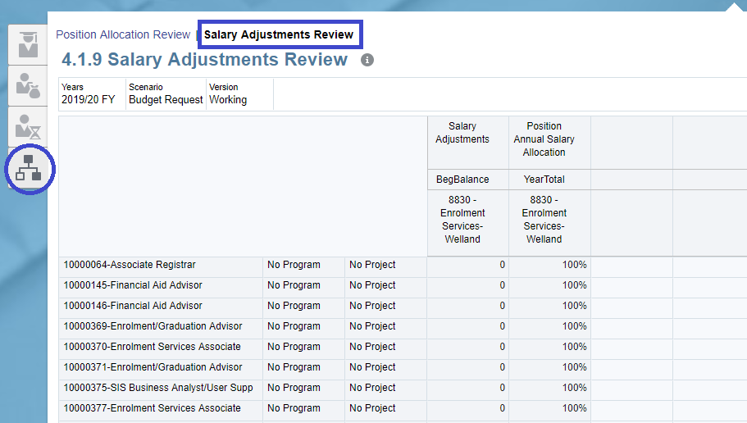

Part-Time Workforce

The purpose of these forms is to track and allocate PT salaries to applicable budgets by job classification. Once this schedule has been completed the total by Department, Program and Project will automatically link to the Budget Request form.

Note: The Admin and Support Staff forms are identical in look and functionality.

Part-Time Admin and Support Staff

On this form you can:
- Make any necessary changes to employee name, job description, hours, and rates. All greyed out fields will calculate after saving the form
- When all changes are completed save them by selecting Save

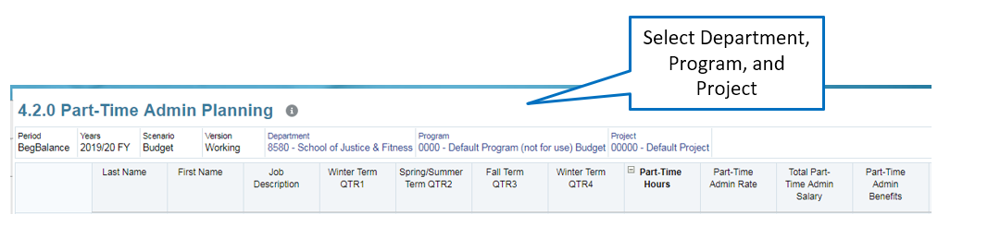

- Add new positions
  - Right-click on a blank row and select Add PT Position. A new blank row will be added
  - In the Select Position drop down choose a Position Number
  - Please Note: The Position Number does not auto populate. Make sure that you pick the next available position number
  - Populate employee name, job description, hours, and rates. All greyed out fields will calculate after saving the form
  - When all changes are completed save them by selecting Save
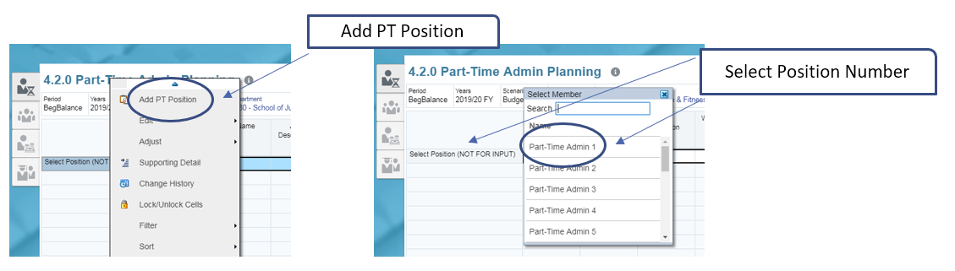

Part-Time Faculty

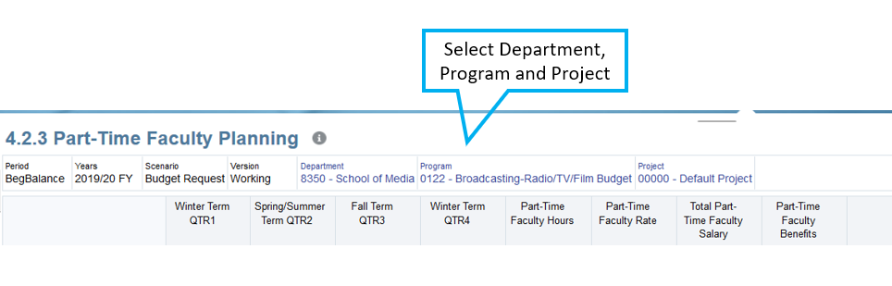

On this form you can:
- Data from AMPS will be prepopulated at a summary level (Not by Position/Employee)
  - This data cannot be changed
- To view position level details right click on any pre-populated records and select Drill Through. Click on the new link that appears called Dill Through to Source. A separate window will appear with employee and course level details.

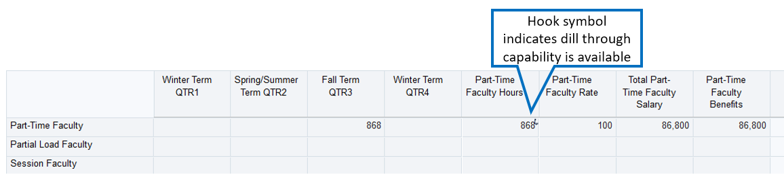

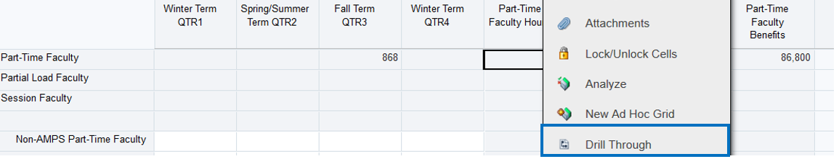

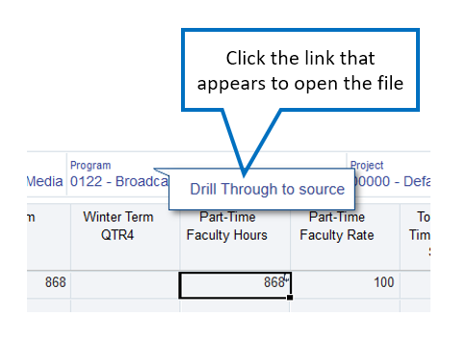

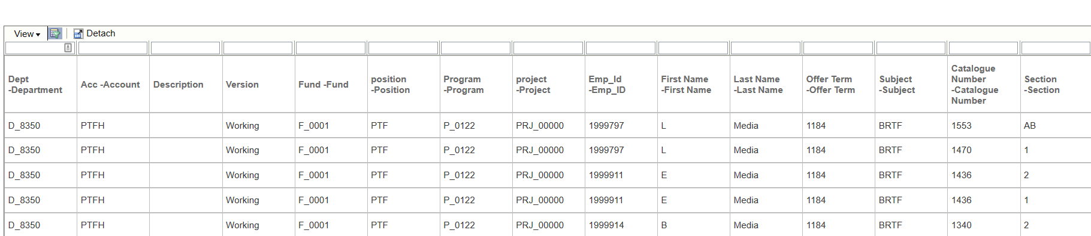

- Add any non-Amps part-time faculty hours
  - Make any necessary changes to hours and rate. All greyed out fields will
calculate after saving the form.
  - When all changes are completed save them by selecting Save.

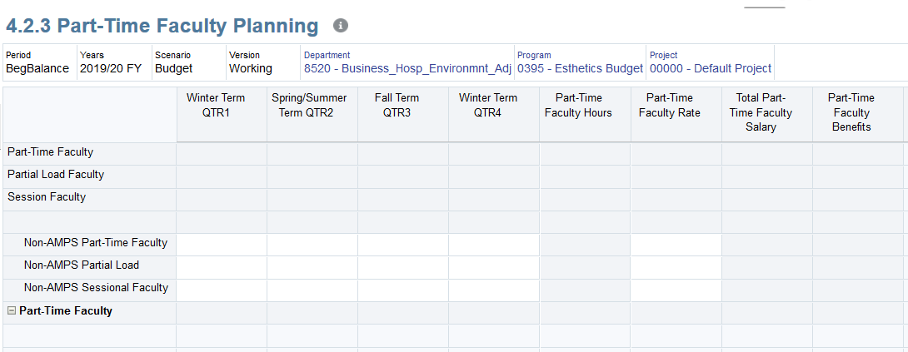

Part-Time Students

On this form you can:
- Make any necessary changes to job description, number of students, hours, and rates. All greyed out fields will calculate after saving the form.
- When all changes are completed save them by selecting Save

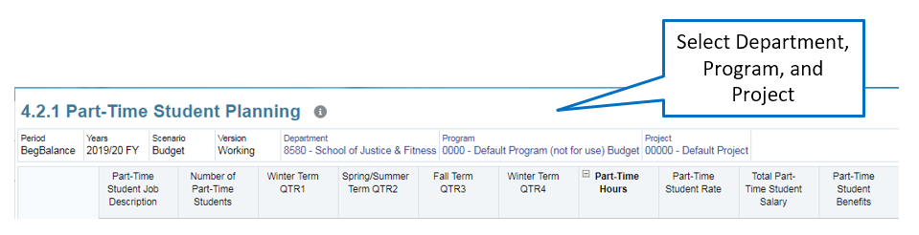

- Add new positions
  - Right-click on a blank row and select Add PT Position. A new blank row will be added
  - In the Select Position drop down choose a Position Number
  - Please Note: The Position Number does not auto populate. Make sure that you pick the next available position number
  - Populate job description, number of students, hours, and rates. All greyed out fields will calculate after saving the form
  - When all changes are completed save them by selecting Save

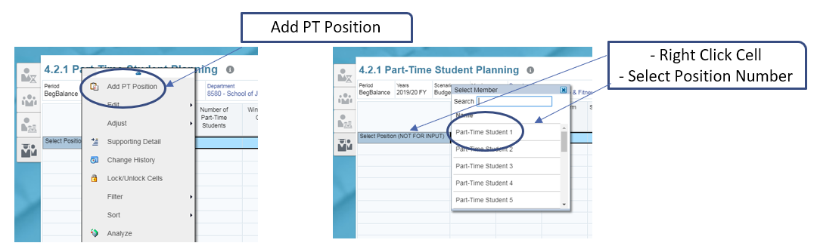

Capital Expenditure Requests

Access the CapEx Planning form on the Budget Development cluster on the PBCS Home Page:

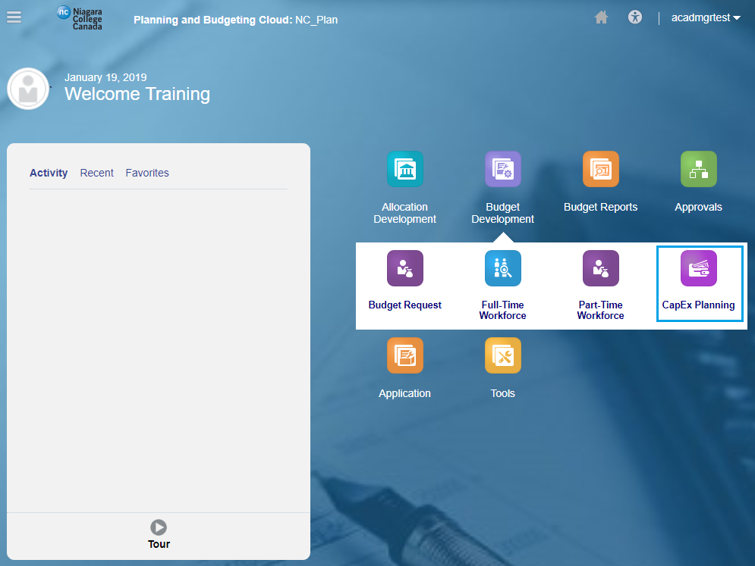

On the CapEx Request forms, you can:

- Create a Capital Expenditure request
- View the approval status of your requests
- Track your capital requests against the capital allocation

CapEx Request

Create a Request

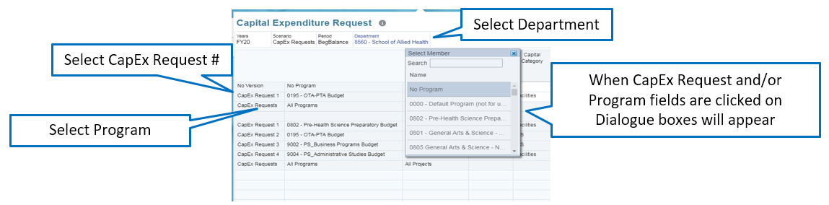

- Select a Different Department if necessary
- Right click on a blank row and select Add New Capital Request. A new blank row will
be added
Please Note: Select the next sequential number for each CapEx Request. This field does not auto-populate.
- Select a Program from the drop down field
- Populate all applicable white space fields
- When all changes are completed save them by selecting Save

Viewing Approved Requests

On the same CapEx Request form, Approved requests will display at the bottom of the form.

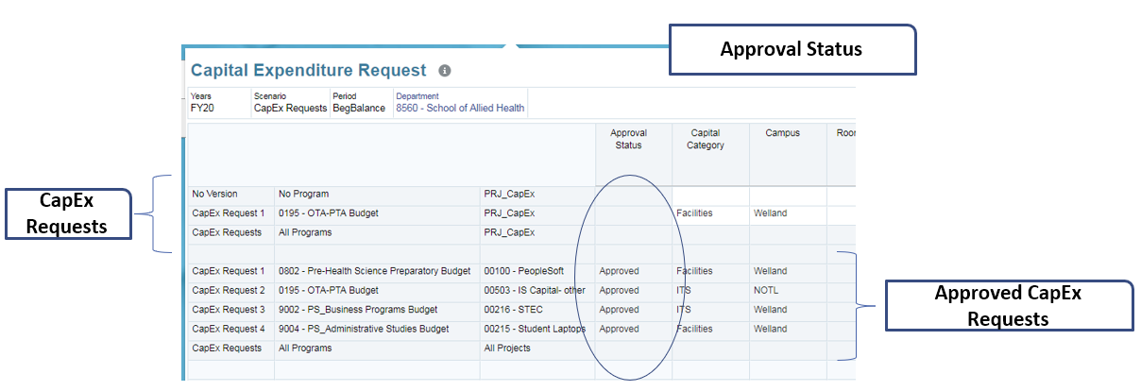

- When a CapEx Request is approved, the Approval Status field will display Approved and a Project and Reference Number will be assigned. The budget will be allocated to the chartfield indicated.

Tracking Capital Allocation

To view your divisional allocation, click on the CapEx Ticker icon the Capital Planning form:

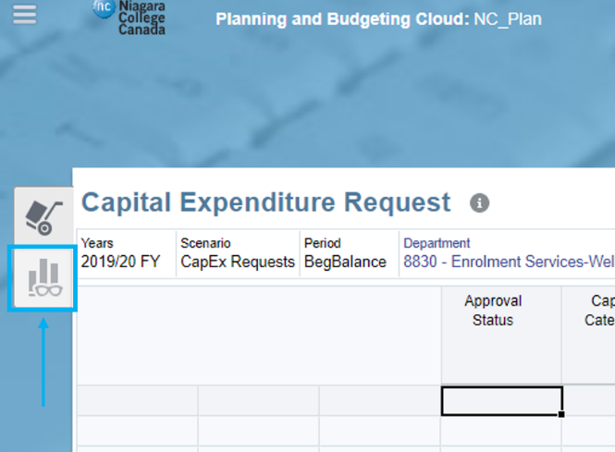

The chart depicts the expense allocation for the division and the remaining allocation based on the difference between the allocation and submitted division expenses.

- This chart depicts the CapEx allocation for the division, the sum of all submitted CapEx Requests and the difference between the allocation and submitted requests

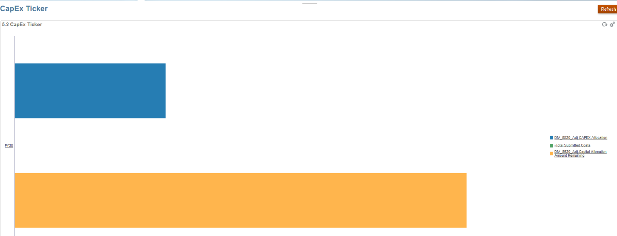

Budget Request

Budget Request Form

Access the Budget Request form from the Budget Development cluster on the PBCS Home Page:

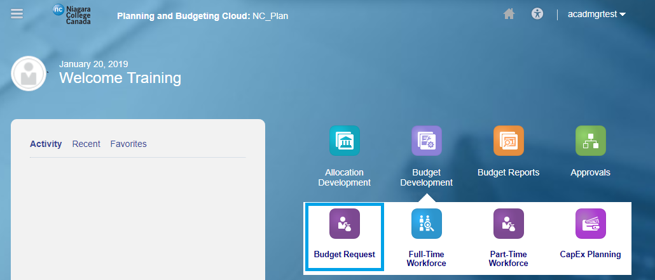

This form is where you will be completing your budget request. Within this worksheet you also have the capability to view historical financial information including 2 full years of historical actuals and actual activity up to and including November 30th of the current fiscal year. This is to assist budget holders in identifying trends to help plan for the upcoming budget submission.

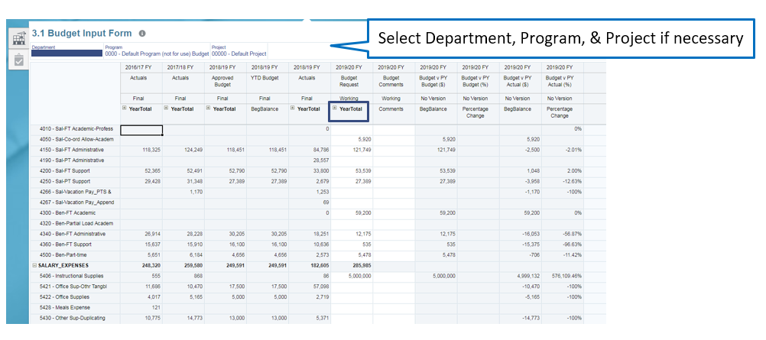

This form is a summation of all expenses within a Department, Program, and Project.
- Select a Different Department/Program/Project if necessary
- Any white cells can be adjusted. Grey cells contain either historical data or data that comes from other forms (Workforce or CapEx)
- Data can be entered in the year total field which will spread data evenly across the months or based on the existing data
- Expand the YearTotal column to view/edit down into the Quarter and Monthly values.
- If you need to an account to budget for, right-click anywhere on the form and click Add Account. In the window that opens enter the new Account Number and click Launch. This will add a row to the form for the new account

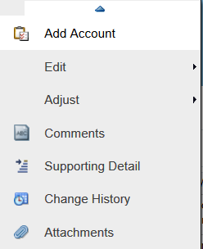

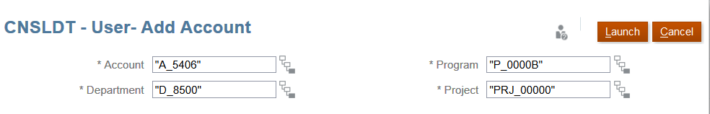

- Comments can be entered at the row level and are used to provide supporting information. This field is not mandatory and is to be utilized at the discretion of the budget holder.
- Supporting Detail can be used to provide item level information for your budget amount entries

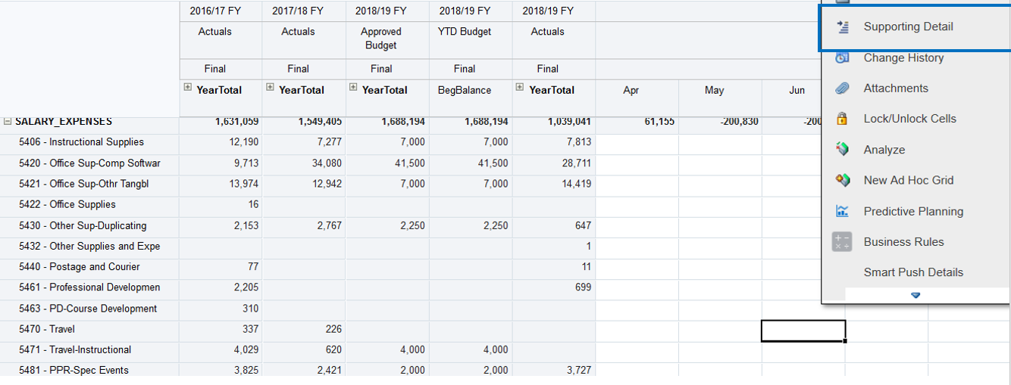

- In the window that pops up click Action and then Add Child. You can now enter individual line items to make up a budget amount. When finished click Save

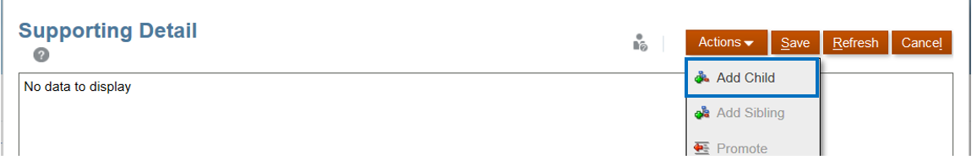

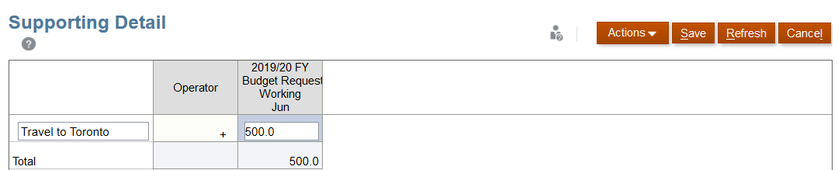

- When all changes are completed save them by selecting Save

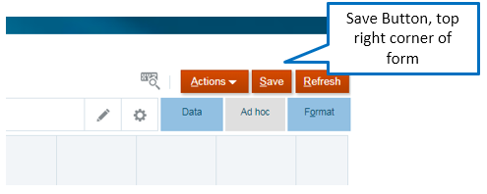

Viewing Divisional Allocation

To view your divisional allocation, click on the Divisional Allocation Ticker icon the Budget Request form.

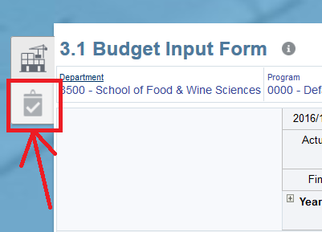

The chart depicts the expense allocation for the division, the total division expenses and the remaining allocation based on the difference between those two.

Please Note: If the difference between the allocation and submitted costs is negative, the division will be able to submit their budget to Finance for review

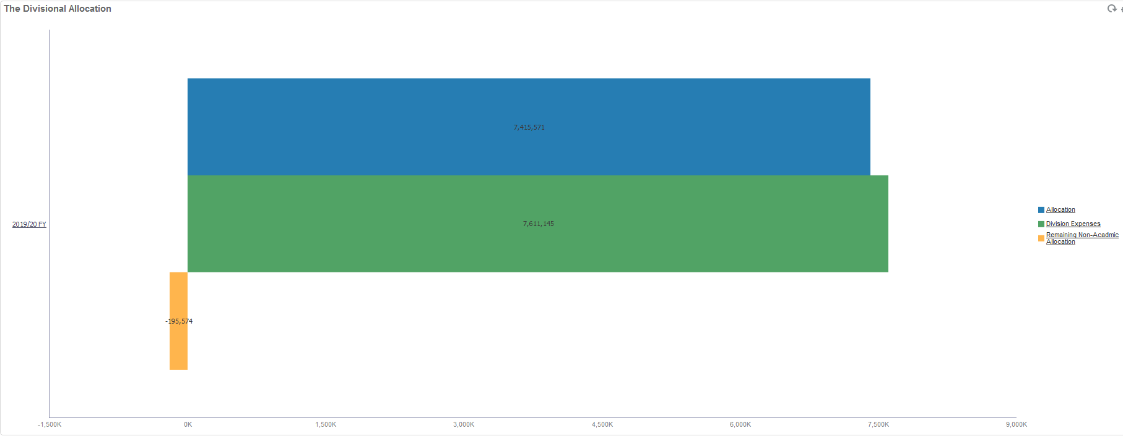

Submitting the Budget

The approval workflow for budget is based on the following:

Department Manager | → | Dean or Director | → | Finance Office
(Submits Department Budget) | → | (Submits Division Budget) | → | (Reviews budget)
VP approval will be coordinated through the Financial Services Office on completion of their review.

Access the Approval Process from the PBCS home page:

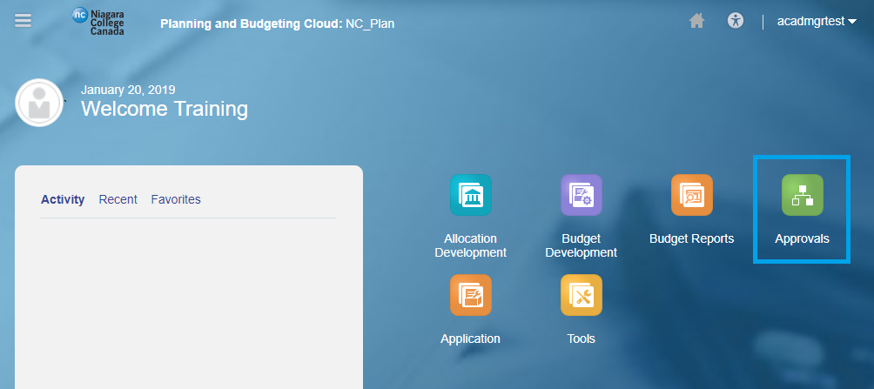

The Approvals screen will show all departments you are responsible for directly or if you are a division manager all the department budgets under your division.

- Click on any department to submit that budget

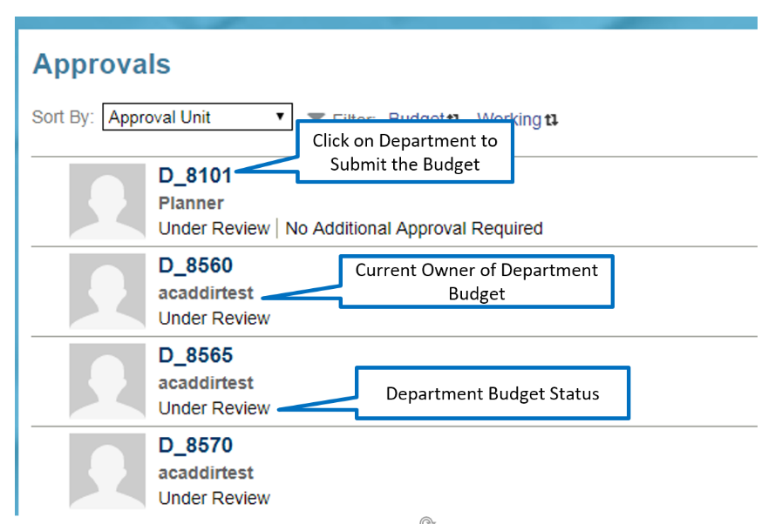

Clicking a Department on the Approvals screen will open a new window for submitting the budget.

- Click on the Action box and select “Promote” to submit the budget
- Add annotations with the submission if desired. This is not required
- Click the Change Status button to submit and Done to close this screen

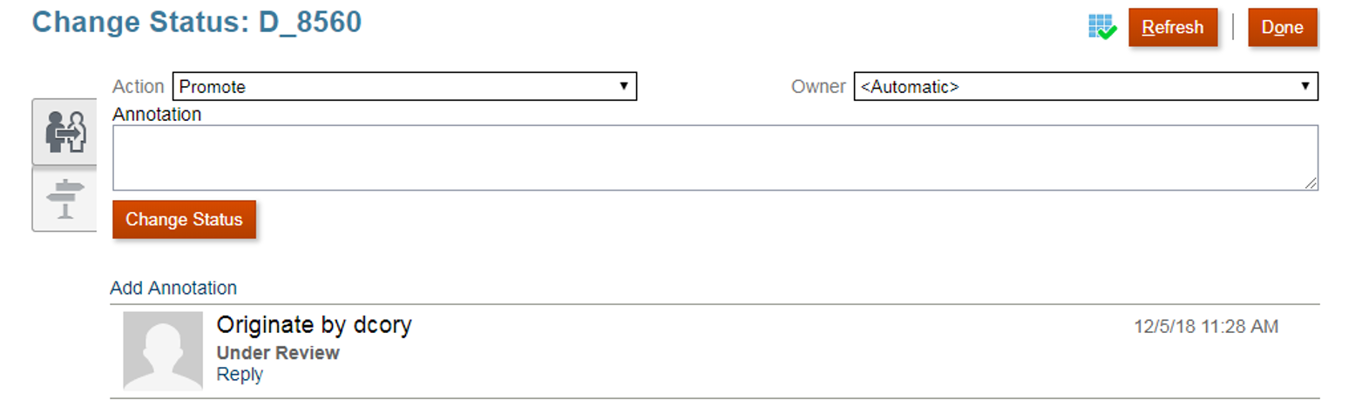

- Divisional managers can Approve or Reject their department budget submissions by clicking on the Department and in the window that appears select either Reject or Sign Off as the Action
- Division budgets are submitted to Finance the same way that Department Managers submit budgets to Division Managers – To do this you only need to select your division and submit once for all departments under your division.

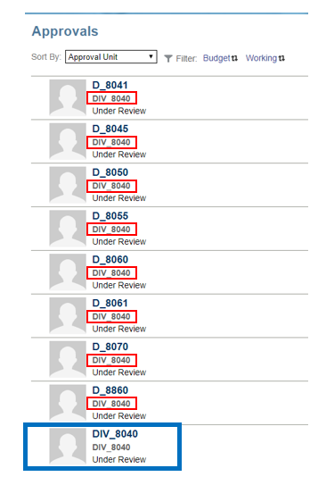
Please Note: If the difference between the allocation and submitted costs is negative, the division will be unable to submit their budget to Finance for review.

Please Note: The budget will be locked for a user once it has been submitted. Users will be able to view, but not edit their budgets. If changes are required after the budget has been submitted these changes will need to be incorporated into the budget by Financial Services.

Running Reports

Access Reports from the Budget Reports cluster on the PBCS Home Page:
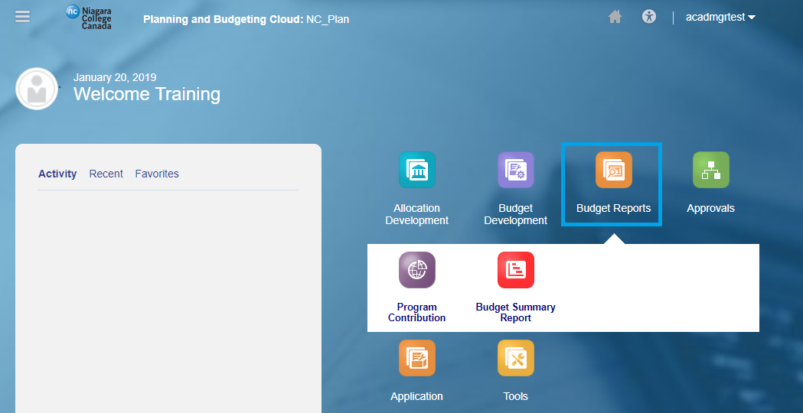

- Reports can be run in HTML, PDF or Excel format
- In PDF view hover over the report with your mouse until the printer icon appears
- Select a different Department if necessary
- Please Note: The Budget Summary Report is the only report available as of the creation date of this document. It is a Divisional report and a Division must be selected. Selecting a Department will cause an error and the report will not run.

