

Niagara College
Training Manual – PBCS NC In-Year Financial Management Module

Table of Contents

Introduction to PBCS 3
What is PBCS? 3
PBCS and Dimensions 3
PBCS Dimensions at Niagara College 3
Accessing PBCS 4
Home Page Overview 5
Setting PBCS Preferences 7
User Preferences 7
Navigating Forms 10
Changing Point of View 10
Entering Data 12
Entering Comments 12
In-Year Financial Management 13
Current Year Forecast 13
Viewing Divisional Allocation 18
Capital Expenditure Requests 19
CapEx Request 19
Create a Request 19
Viewing Approved Requests 20
Tracking Capital Allocation 20
In-Year Allocations 22
Viewing Dashboards 24

Introduction to PBCS

What is PBCS?

Oracle Planning and Budgeting Cloud Service (PBCS) is a web-based planning solution that drives collaborative, event-based planning and forecasting models.

PBCS is an all-in-one tool for the end-to-end and closed-loop planning process that drives continuous business improvement.

PBCS provides the ability for all front-line managers to communicate the appropriate course of action to take and allows the budget holders to collaborate so that the planning process is streamlined and efficient.

PBCS and Dimensions

PBCS is a multidimensional database server optimized for planning, analysis and management reporting applications. PBCS utilizes dimensional hierarchies and consolidates data. Plan data entered into the application is then stored in a multidimensional database.

Dimensions are the actual descriptors of the base elements that describe and store data. Years, Scenario, Departments, Programs and Accounts are all examples of dimensions.

Within each dimension, the individual elements are called members.

PBCS Dimensions at Niagara College

Dimension | Purpose
Account | Based on the Chart of Accounts from PeopleSoft, as well as drivers and statistical accounts
Department | Contains the hierarchy for Divisions and Departments
Fund | Distinguishes the fund. There is currently only one fund
Period | Specifies the periods of the fiscal year or academic terms such as months, quarter and total year
Position | Used to capture Employee and Position information
Program | Defines Academic and Non-Academic Programs
Project | Defines the project
Scenario | Specifies a data classification:  - Actual – actual data loaded from PeopleSoft  - Budget – Reflects budget or inputs from users  - Forecast – Corresponds to predictions for upcoming periods
Version | To allow multiple iterations of a plan, modeling possible outcomes, managing dissemination of data and facilitating target setting
Years | Corresponds to the fiscal year

Accessing PBCS

Planning and Budgeting is cloud-based and can be accessed via any computer with internet access.

PBCS can be accessed through the Niagara College portal:

https://portalnc.niagaracollege.ca/

Login to the Portal using your Niagara College credentials and click on the More Applications icon at the top:

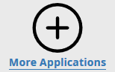

Expand the All link and click on the PBCS icon - If you would like to favorite the link to appear on your home page, select the star:

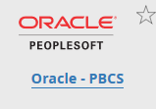

This will take you directly to the application Home Page.

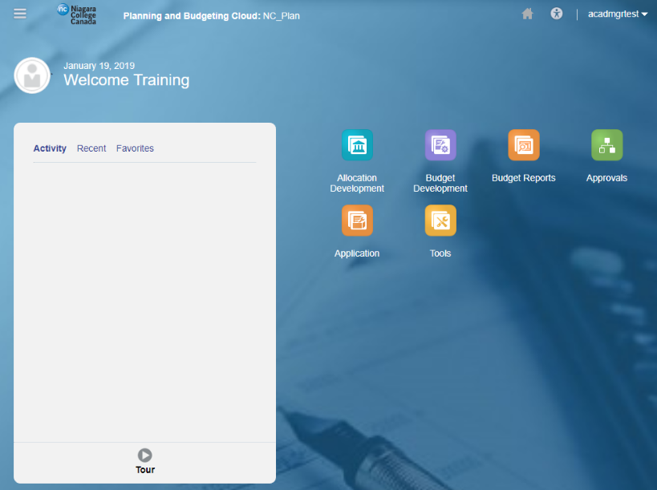

Home Page Overview

The navigation flow is made up of clusters and cards:

- Cards represent the different objects in Planning and Budgeting, such as forms, reports, and dashboards.
- Clusters are a grouping of cards. Each cluster groups like business processes.

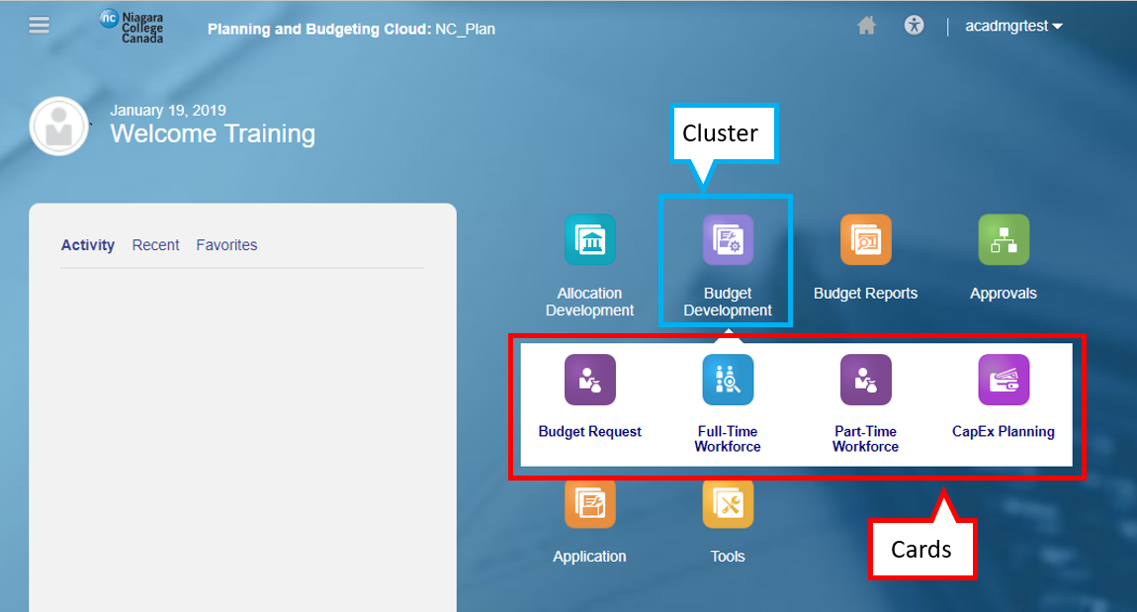

You may return to the home page by:

- Clicking the Niagara College logo
- Clicking Home

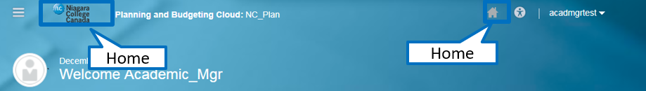

The Navigator shows all forms, tools, and preferences available within Planning and Budgeting.

- While you have access to Navigator, it is recommended you use the navigation flows to carry out all budgeting tasks.

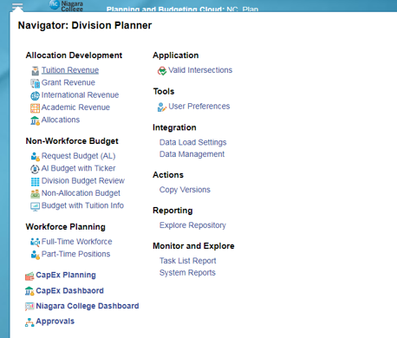

The Activity Pane shows a list of recent activity and favorited objects. To favorite an object, click on the star icon.

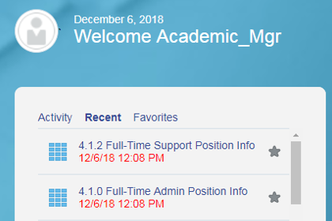

Setting PBCS Preferences

To access Preferences, click the Tools cluster, then select the User Preferences card.

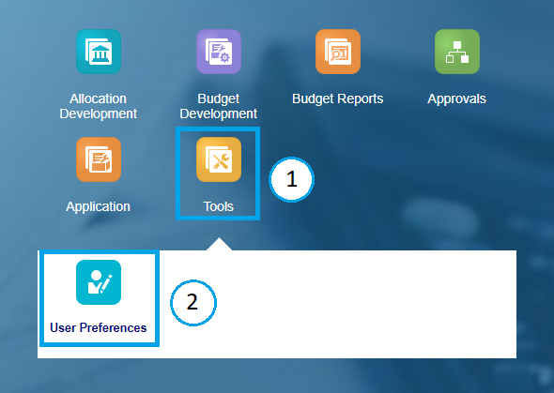

User Preferences

Note: While there are many Preference options, generally you can choose the Administrator’s Settings for Application Defaults. However, these are some recommended user specific settings;

- General – Set time zone to Eastern Standard Time and select Use Administrator’s Settings under Alias Setting and Approvals

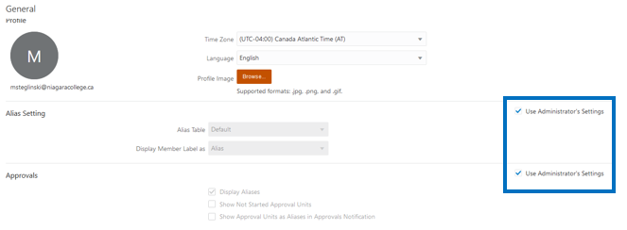

- Display – Select Use Administrator’s Settings under Number Formatting, Page Options and Other Options

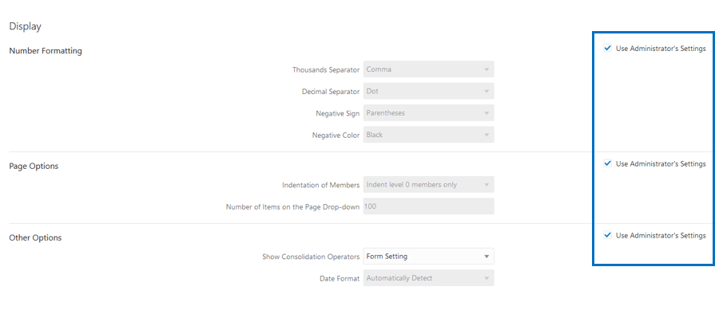

- Notifications – Enter your e-mail address and select Use Administrator’s Settings to receive system notifications

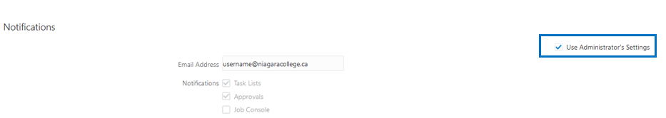

- User Variables – Act as filters in forms, enabling users to only see data and information that are relevant to them.

- When you open a form, the members you set as user variables will already be set in the form.

User variables only need to be set once, but they can be changed at any time. Members can be selected for each dimension by clicking Member Selector.

Recommend Settings;
- BA_Department: Select the Division that contains the Cost Centers you submit
- BA_DivisionAllocation: Select the Division that contains the Cost Centers you submit
- BA_Program: Select the Programs associated with the Departments you budget. If you are part of a non-academic division, select the default program budget - 0000
- BA_ Project: Select the Projects associated with the Departments you budget
- Fund: Select ‘Fund 1’

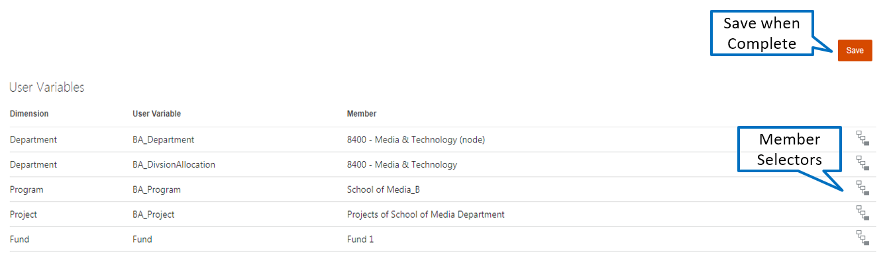

Members can be selected in two ways from the Member Selection window:

- Key in a value on the Search Bar
- Select from Hierarchy and check the member. For all selections click just to the left of the member until a check mark appears

With either method you can confirm your selection at the top left portion of the window before clicking OK.

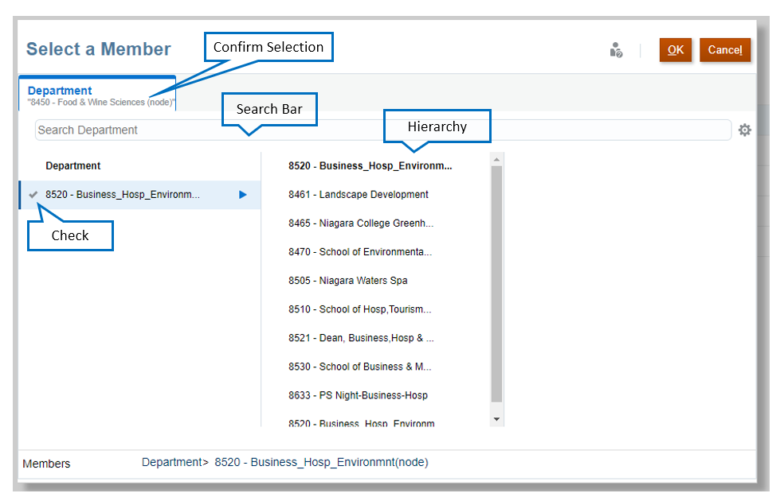

Navigating Forms

Forms in Planning and Budgeting have the following structure:

- The navigation toolbar allows you to navigate to the other cards in that cluster.
- The Point of View (POV) defines the section of data in the Planning and Budgeting database you are viewing. You select the desired members for each dimension to determine the context for the pages, rows, and columns. NOTE: The default POV is defined by the user variables you set.

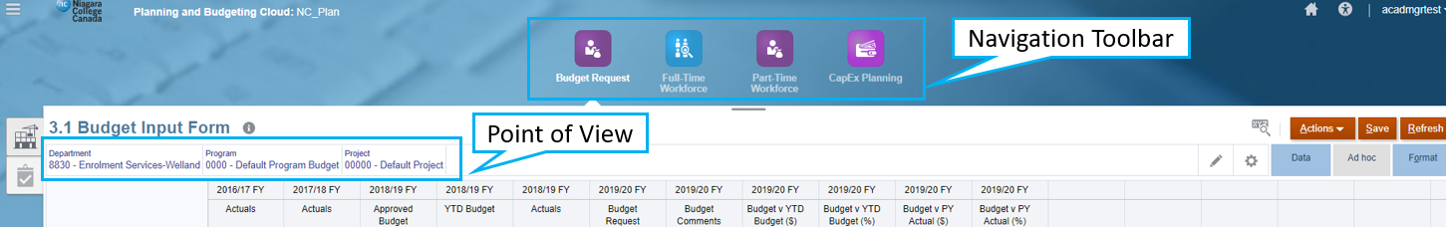

Changing Point of View

- To select the POV, click Edit Members. The Edit Members window is displayed.
- To select different members for the dimension, click the dropdown next to each dimension. Select the desired member from the list of available members.

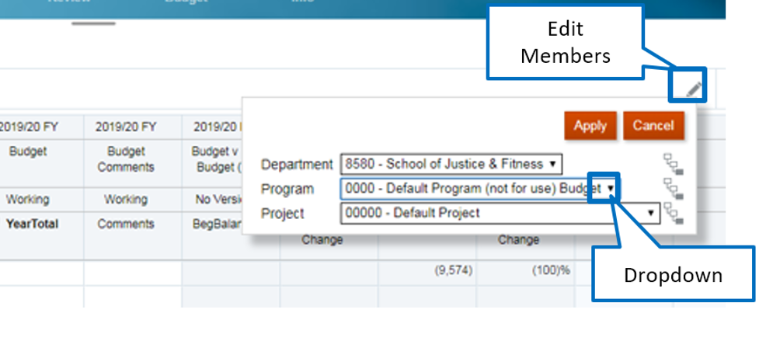

- Once the desired member is selected, click Apply.

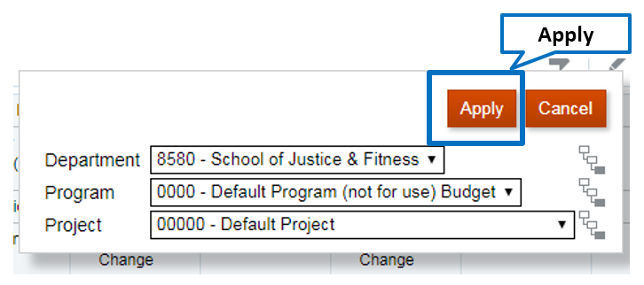
Alternatively, members can be selected for each dimension by clicking Member Selector

In the member selector, a selection can be made in two ways:

- Type the member in the Search Bar
- Drill through the hierarchy and check the member desired
  - Select the triangle at the right of a member expands the hierarchy across the screen
  - Select a member by clicking just to the left of the member and a blue check mark will appear

In either case confirm the selection at the top left of the screen and click OK

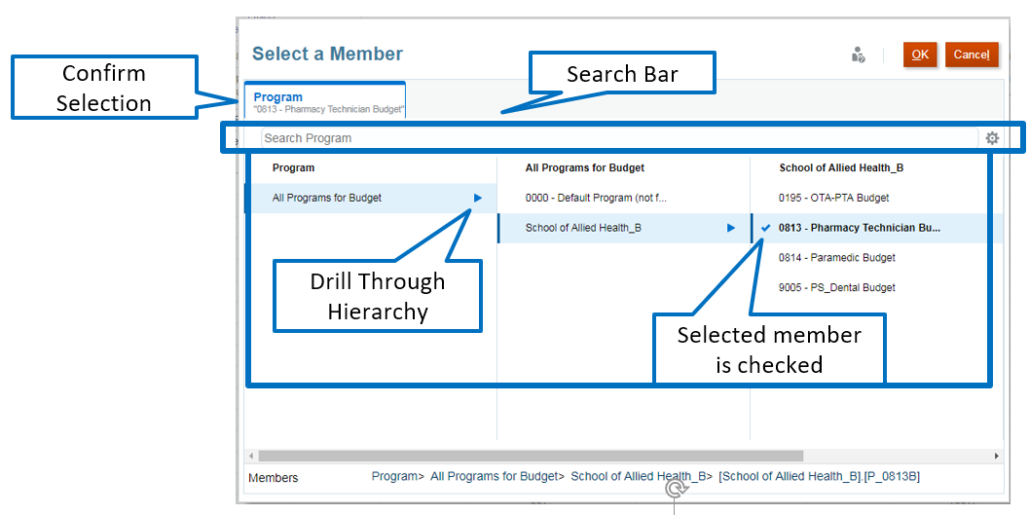

Once you return to the form you will see the member you edited highlighted in yellow indicating a change has been made but not actioned. Click the arrow to update the form with your POV selection.

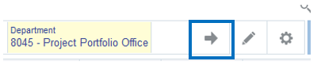

Entering Data

Cells display the data for the selected members. Cell colors indicate the cell’s status:

- White: default; data can be entered into these cells
- Yellow: values changed but data is not yet saved
- Grey: read-only cells
- Grey with a Lock Symbol: locked cells
- Teal: cells have supporting detail

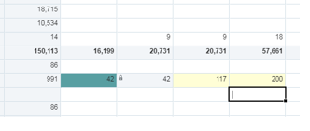

Entering Comments

To add or view comments:

- Right-click on desired input cell
- Click Comments
- A small window will pop up. If existing comments have been you will see them here
- Enter comments and click Post
- Cells with comments will have a black corner
- To delete a comment, click on the Delete link that appears in the comments pop up window

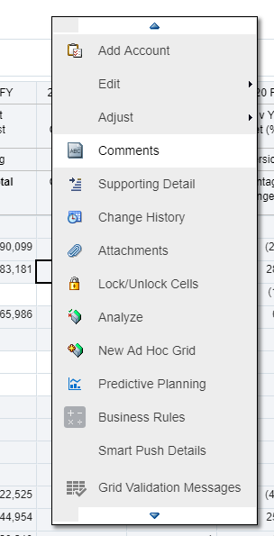 | 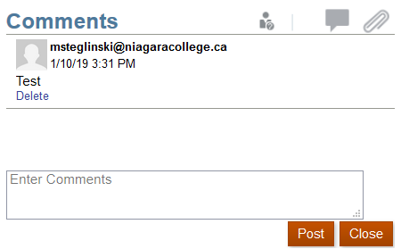

In-Year Financial Management

Current Year Forecast

Access the Current Year Forecast form from the In-Year Management cluster on the PBCS Home Page:

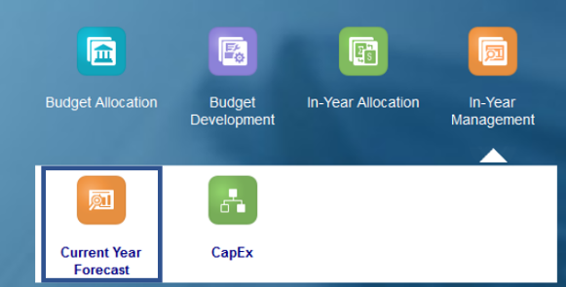

On this form you can enter year to date budget adjustments as well as track performance against your approved budget using current actuals. Similar to the budget process there is an allocation assigned to each division and the system will not allow you to make any adjustments that will cause your division to exceed that value.

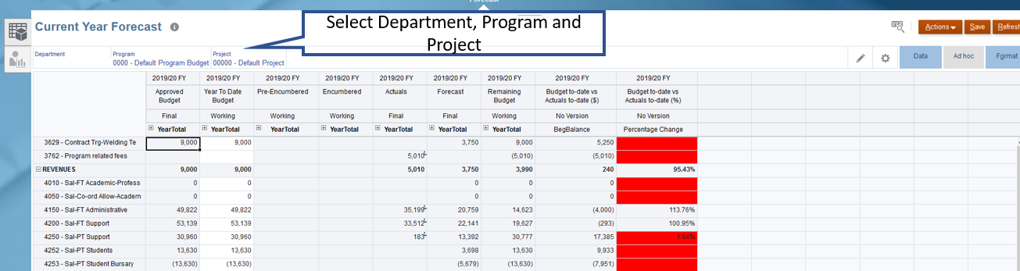

If an adjustment is made that does exceed the divisional allocation, the error message below will be displayed and you will need to revise the adjustment(s) made to remain within allocation.

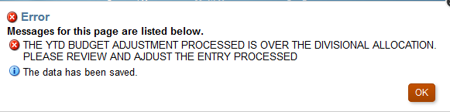

This form is a summation of all expenses and revenue within a Department, Program, and Project by account.
- Select a Different Department/Program/Project if necessary
- Any white cells can be adjusted. Grey cells contain either actuals data or data that comes from other forms (Approved Budget or CapEx)
- Data can be entered in the YTD Budget year total fields which will spread data evenly across the months or based on the existing data
- The Forecast Column represents a system generated forecast that includes actuals for the open months and budget for the closed months. For example, if you are entering the form in November the forecast would be comprised of Actuals from April to October, and the monthly budget from November to March. Material variances between Budget and Forecast may require further explanation.
- The Remaining Budget column is calculated as YTD Budget less Pre-Encumbrances, Encumbrances and Actuals. This represents the amount of budget remaining for the duration of the fiscal year.
- The Budget to Date vs Actuals to Date column represents YTD Budget to Date less Actuals to Date. A negative value in this column represents spending more than planned and a positive value represents spending less than planned.
- Expand the YearTotal column to view/edit down into the Quarter and Monthly values.
- If you need to add an account to budget for, right-click anywhere on the form and click Add Account. In the window that opens enter the new Account Number and click Launch. This will add a row to the form for the new account

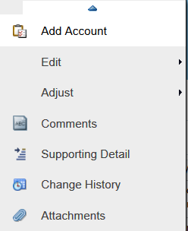

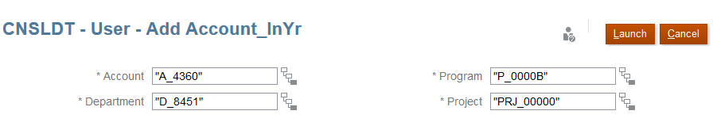

- Comments can be entered at the row level and are used to provide supporting information. This field is not mandatory and is to be utilized at the discretion of the user.
- Supporting Detail can be used to provide item level information for your YTD Budget amount entries. Note – Supporting detail can only be entered at the monthly level for an account

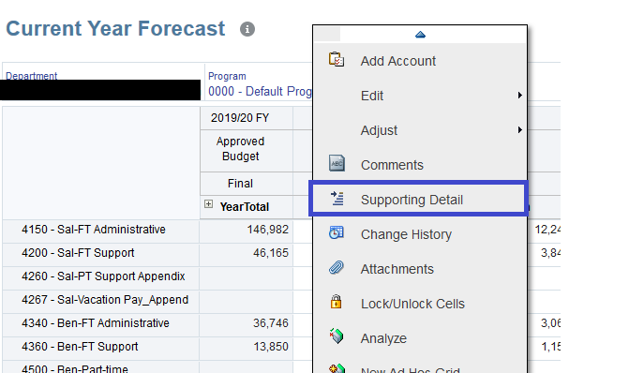

- In the window that pops up click Action and then Add Child. You can now enter individual line items to make up a budget amount. When finished click Save

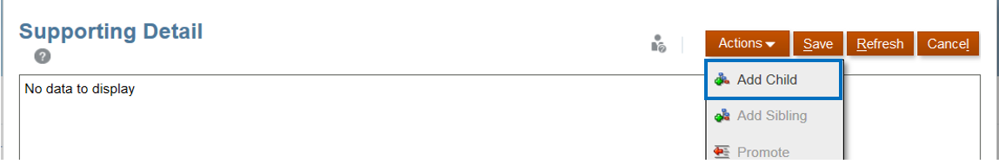

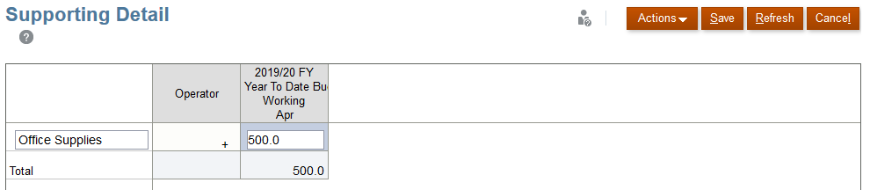

- When all changes are completed save them by selecting Save

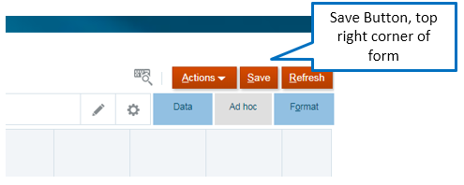

- To view encumbrance, pre-encumbrance or actuals details right click on any cell under those columns and select Drill Through. Click on the new link that appears called Dill Through to Source. A separate window will appear with employee and course level details.

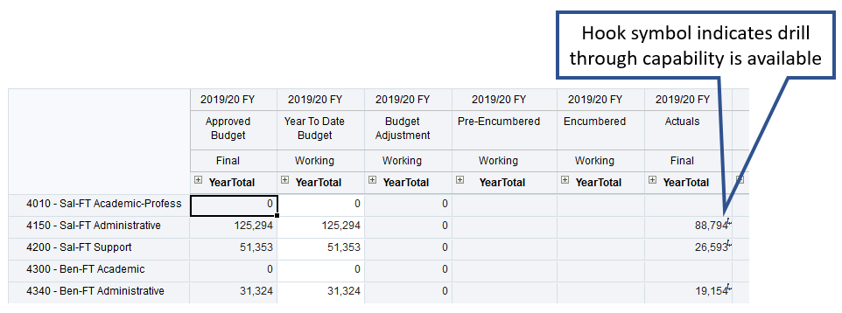

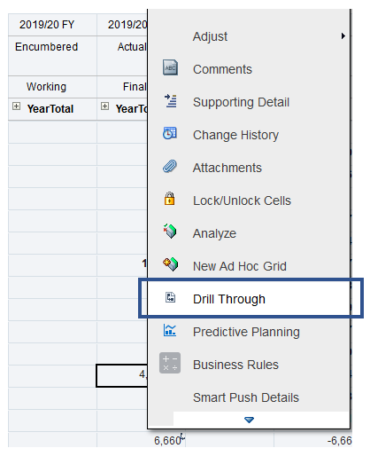

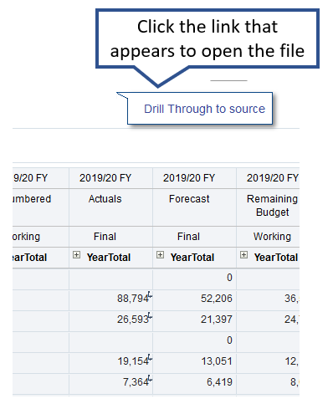

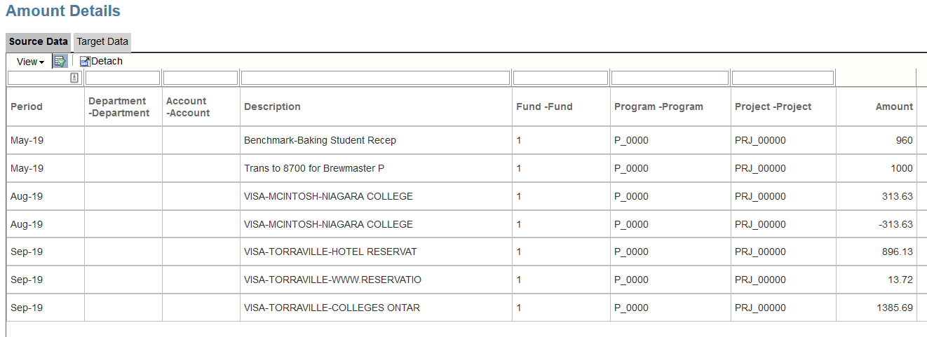

To add additional columns to the View click on View -> Columns and scroll through the list until you find the field you would like to add and select it.

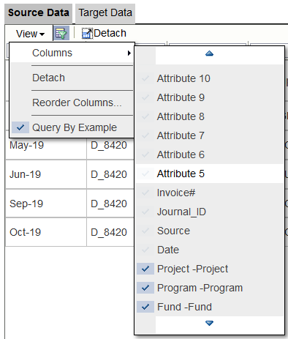

To export the sheet to Excel click on the cog icon for the header row and select Export All to Excel

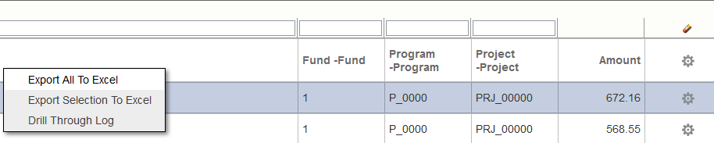

Viewing Divisional Allocation

To view your divisional allocation, click on the In-Year Divisional Ticker icon the Current Year Forecast form.

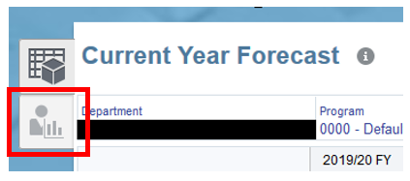

The chart depicts the expense allocation for the division, the total division expenses and the remaining allocation based on the difference between those two. This chart is live and depicts all updates that are made to the YTD budget.

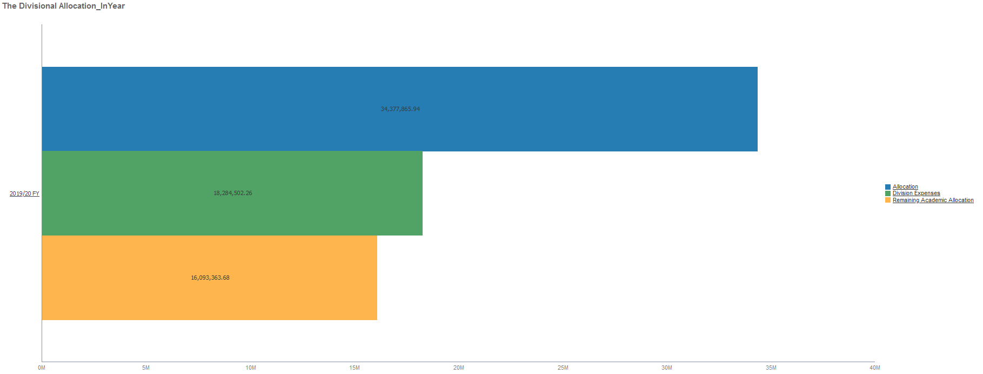

Capital Expenditure Requests

Access the CapEx Planning form on the In-Year Management cluster on the PBCS Home Page:

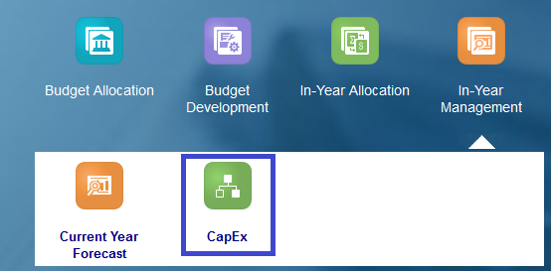

On the CapEx Request forms, you can:

- Create a Capital Expenditure request
- View the approval status of your requests
- Track your capital requests against the capital allocation

CapEx Request

Create a Request

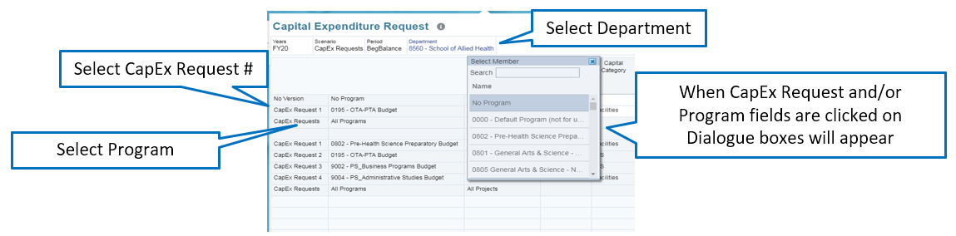

- Select a Different Department if necessary
- Right click on a blank row and select Add New Capital Request. A new blank row will
be added

Please Note: Select the next sequential number for each CapEx Request. This field does not auto-populate.

- Select a Program from the drop down field
- Populate all applicable white space fields
- When all changes are completed save them by selecting Save

Viewing Approved Requests

On the same CapEx Request form, Approved requests will display at the bottom of the form.

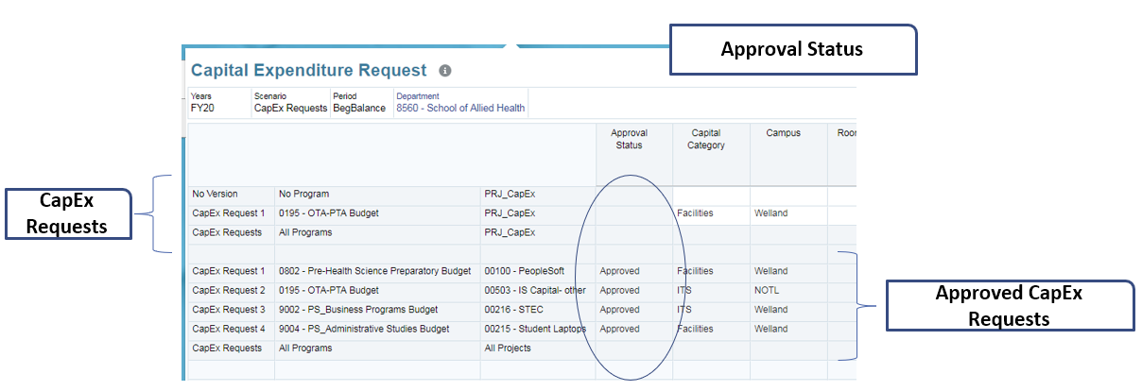

- When a CapEx Request is approved, the Approval Status field will display Approved and a Project and Reference Number will be assigned. The budget will be allocated to the chartfield indicated.

Tracking Capital Allocation

To view your divisional allocation, click on the CapEx Ticker icon the Capital Planning form:

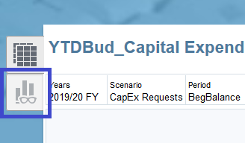

The chart depicts the expense allocation for the division and the remaining allocation based on the difference between the allocation and submitted division expenses.

- This chart depicts the CapEx allocation for the division, the sum of all submitted CapEx Requests and the difference between the allocation and submitted requests

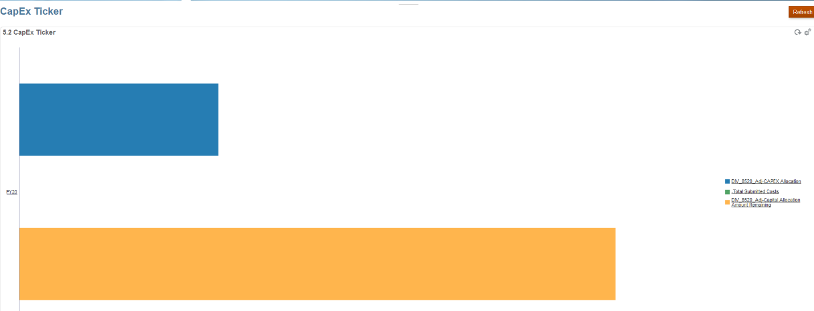

In-Year Allocations

The In-Year Allocation forms follow the same look and process as they did in the budget process but now show updated values based on actual enrollment numbers and new projections. The allocation for Academic divisions will be updated each term once 10th has passed and an updated enrollment forecast has been provided by the Registrar for subsequent terms. Non-academic allocation update will occur as required.

New functionality is found the Historical card.

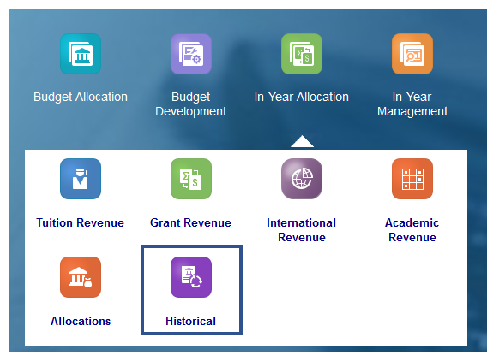

Upon opening the Historical card you will be taken to a form that displays all of the other allocation forms

- Tuition Revenue
- Grant Revenue
- International Revenue
- Academic Revenue
- Allocations

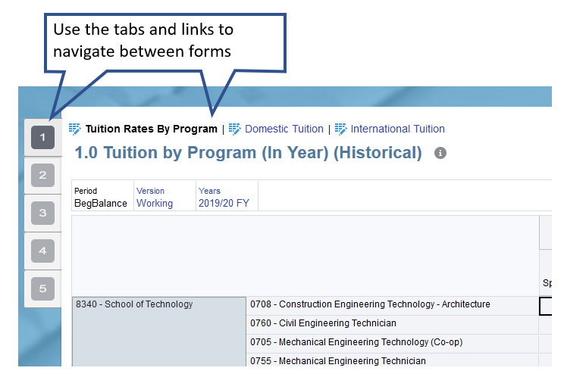

On any of the forms you can change the Version or Year dimensions by clicking on the values under the heading. Changing these will allow you to look at different historical data sets.

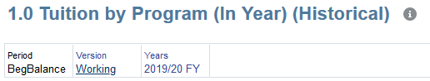

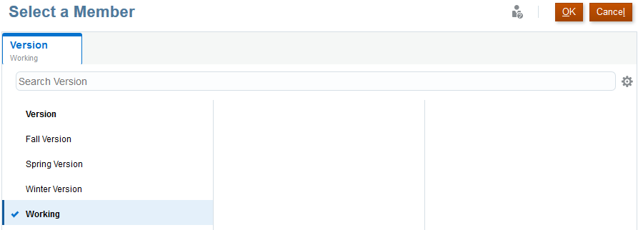

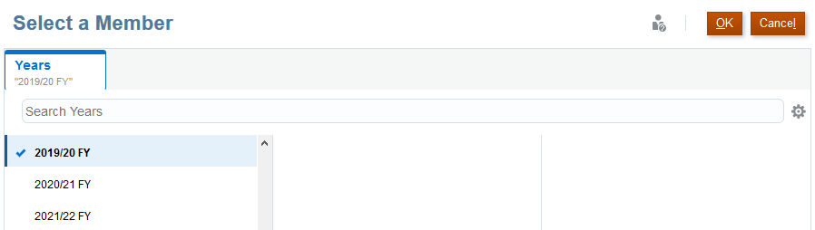

After making your selections click the arrow button to refresh the form.

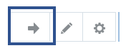

Note – Once you change the point of view on one form it will carry those values to any of the other forms you navigate to on the Historical card.

Viewing Dashboards

Access Dashboards from the In-Year Reports cluster on the PBCS Home Page:

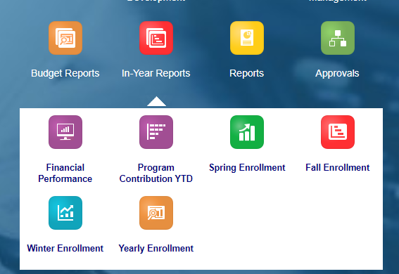

- Click on the card of the dashboard you would like to view
- Note – Some dashboards are only available to academic departments and divisions

